**Week_2 - ServiceNow – Hands _ On**

**TOPIC** : 1

**ServiceNow Admin Full Course** :

Learn ServiceNow Administration Platform Overview and Architecture, User Interface and Branding, List & Filters and Forms, Task Management, Notifications, Knowledge Management, Service Catalog, Tables and Fields, Access Control List, Data Import, CMDB, Integration, Update Sets, Events, Platform Stats

**What is ServiceNow?**

• ServiceNow is a cloud based ITSM platform that supports IT service management (ITSM) and automates common business process and provides best service to customers and encourages best practices in managing all services as a business.

• ServiceNow is a cloud-based workflow automation platform that enables enterprise organizations to improve operational efficiencies by streamlining and automating routine work tasks.

**Employees**

ServiceNow employs over 17,000 people across the globe Glass door BEST PLACES TO WORK 2022

In 2022, ServiceNow was recognized as one of Glassdoor's Best Places to Work in both the United States and the UK. FORTUNE

In 2021, ServiceNow was one of FORTUNE magazine's World's Most Admired Companies, Future 50 companies, and 100 Best Companies to Work For

**Who is ServiceNow?**

Bill McDermott

Currently serving as the CEO of ServiceNow

Formerly CEO of SAP SE where during his tenure the company's market value increased from $39 billion to $156 billion

**Who is ServiceNow?**

Fred Luddy

ServiceNow founder and current board chairman

Born in New Castle, IN

Dropped out of Indiana University

Former CTO of Peregrine Systems

**Why ServiceNow?**

Information Technology (IT)

Usually does not produce revenue

Is an expense (oftentimes the largest)

Exists to enable or enhance the ability of the revenue-producing businesspeople

Is a necessary evil.

What if IT services were designed and delivered in a way that allowed businesspeople to solve business problems themselves.

Is it possible to build a platform where interacting with IT services is intuitive, well-delivered, and enjoyable to work with.

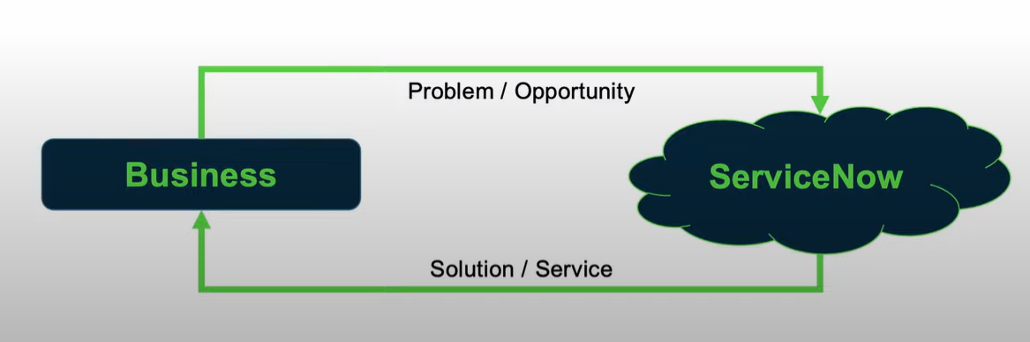

**How service now?**

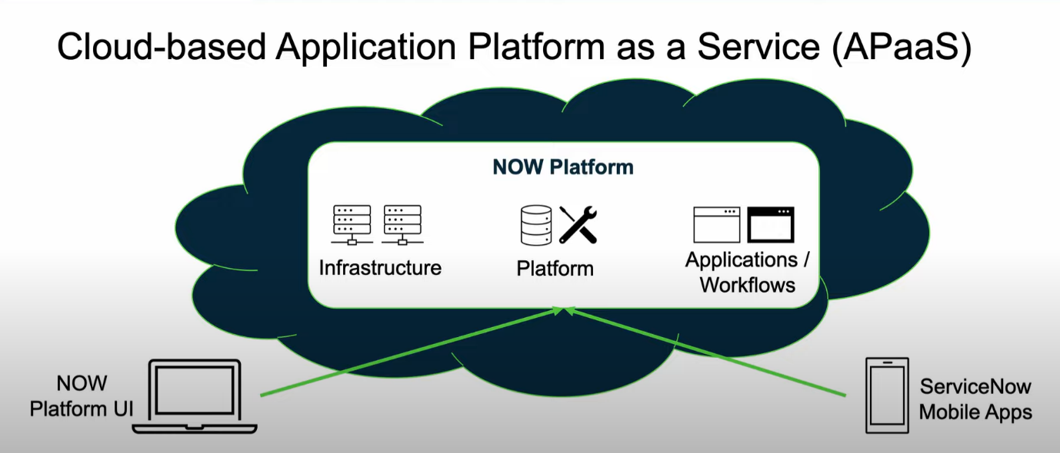

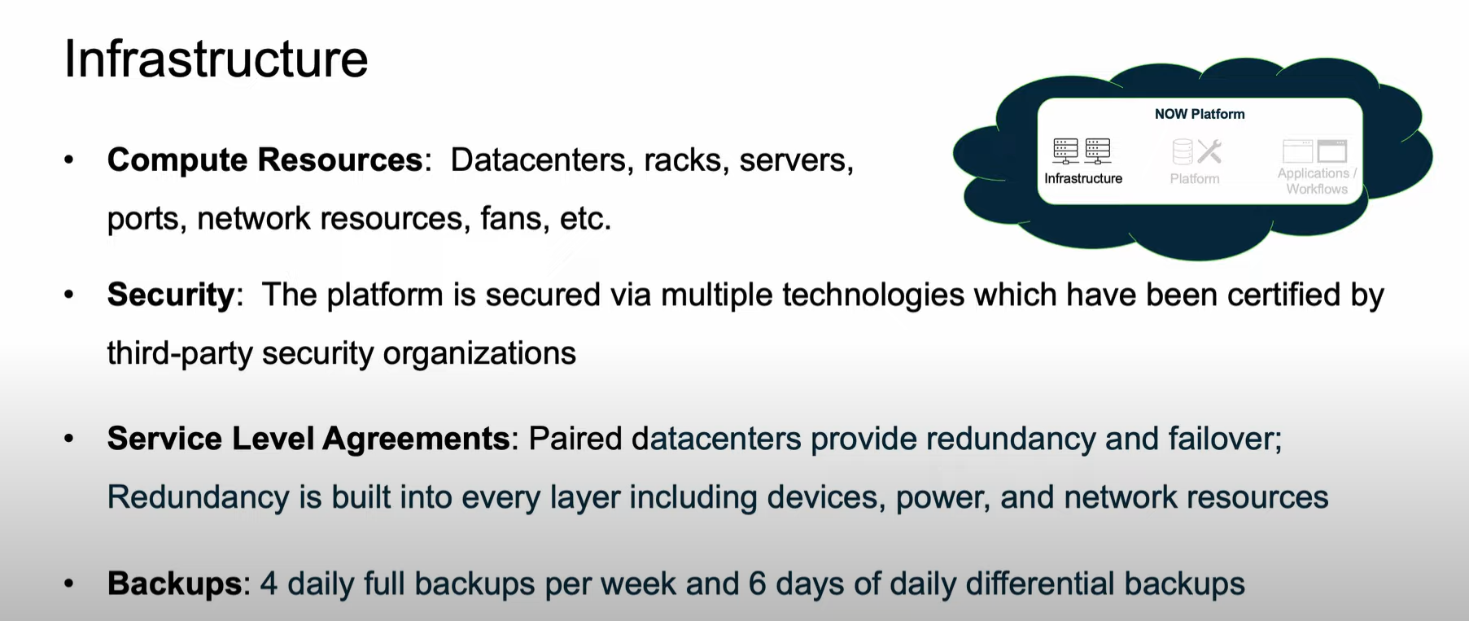

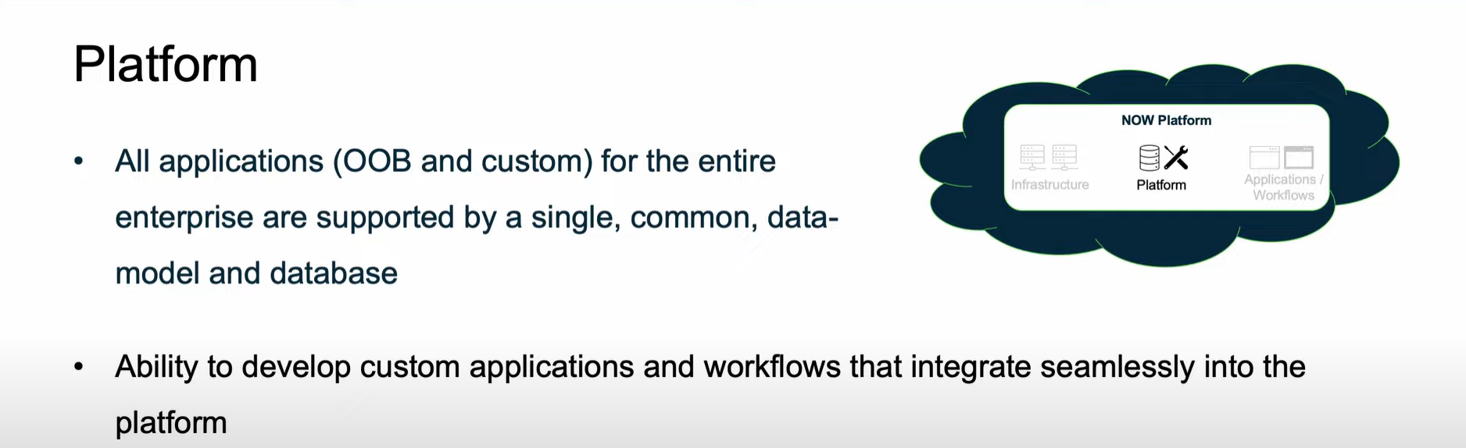

Applications / Workflows

ServiceNow comes with a robust suite of applications which are functionally categorized into 4 primary workflows:

IT Workflows: Service Management (24), Operations Management (13), Business Management (10), Asset Management (4). DevOps (4), Security Operations (8), Governance, Risk, and Compliance (13), Telecommunications Network, Performance Management (3)

Employee Workflows: HR Service Delivery (16), Workplace Service Delivery (10), Legal Service Delivery (10), Procurement Service Management (6), Safe Workplace Suite (1)

Customer Workflows: Customer Service Management (29), Field Service Management (11), Connected Operations (4), Financial Service Operations (25), Telecommunications Service Management (24) Creator Workflows: App Engine (15), IntegrationHub (8)

**Where ServiceNow?**

Headquarters: Santa Clara, California

Office Locations & Employees: Across the globe including North America, Latin America, Europe, Middle-East, Africa, Asia Pacific, Japan

Data Centers:

Asia Pacific Japan: Australia, Hong Kong, Japan, Singapore, India

Europe, Middle East, Africa: Germany, Ireland, Netherlands, Switzerland, UK

North America: Canada, USA

South America: Brazil

**Conclusion:**

ServiceNow is a software company based in Santa Clara, California, founded by Fred Luddy in 2003, to solve problems large enterprises face with traditional IT delivery by providing a robust, simple to use, cloud-based environment in which businesspeople can solve the business problems themselves.

**The Now Platform**

* The Now Platform is an Application Platform as a Service (APaaS).
* ServiceNow is a cloud-based.
* ServiceNow provides and supports the infrastructure computer resources.
* ServiceNow provides a platform upon which you can develop your own custom solutions.
* ServiceNow provides a robust set of applications and workflows to support most common business processes

All applications (OOB and custom) for the entire enterprise are supported by a single, common, data-model and database.

**Applications and Workflows**

* ServiceNow comes with a robust suite of applications which are categorized (functionally) into 4 primary workflows:
* IT Workflows: 79 applications that support internal IT functions
* Employee Workflows: 43 applications targeted at the needs of employees
* Customer Workflows: 93 applications that support functions related to customers
* Creator Workflows: 23 applications designed to enable ServiceNow platform development and operations support

**Now Platform Architecture**

When you purchase an instance, it is ServiceNow's responsibility to support the IT infrastructure and compute resources needed to enable and secure that instance.

* Enterprise Cloud

Most cloud services are built on a multi-tenant architecture in which your platform and data are co-mingled with other companies. ServiceNow is built on a multi-instance architecture. You have your own instance of the platform and database.

* Availability & Redundancy

All ServiceNow datacenters are paired with another datacenter to provide redundancy and failover. Redundancy is built into every layer including devices, power, and network resources.

**Backups & Security**

ServiceNow provides 4 weekly full data backups and 6 days of daily differential backups. The entire platform Is secured using multiple technologies which have been certified by third-party security organizations.

Domain Separation (multi-tenancy)

The ServiceNow platform provides the ability to separate data, processes, and administrative tasks on an instance into logical groupings called domains.

All users can potentially see records from the 'global domain', but only users who belong to a domain can see domain-specific records.

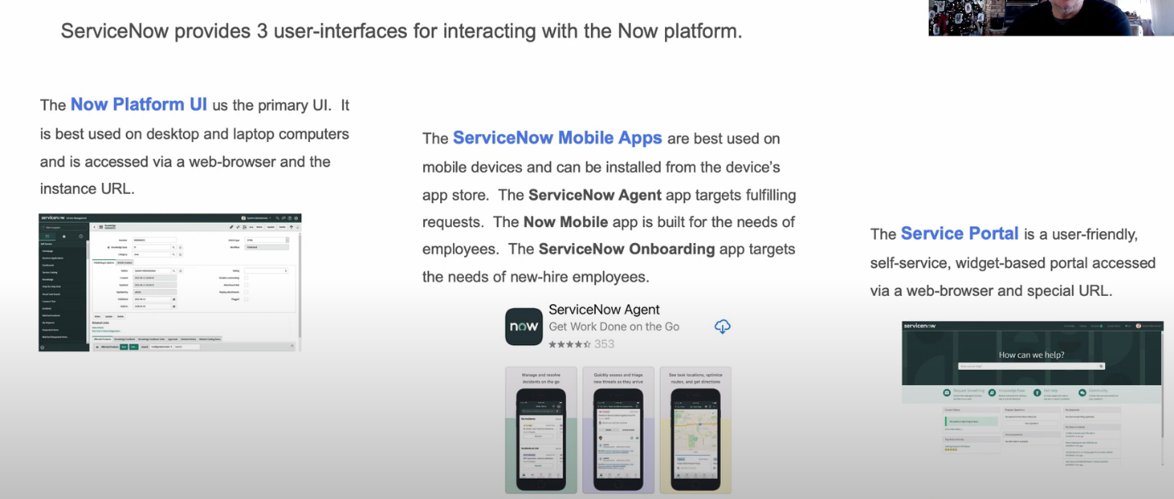

**Role-based Access**

Not every member of an organization needs access to all information all the time. ServiceNow uses role-based access to ensure a user can get the information they need, and no more. The primary components include:

A User is an individual that has been given access to an instance. Users are usually assigned to 1 or more groups and can be granted multiple roles. A user with no roles assigned is called a self-service user. They can login and access actions like viewing the homepage, Service Catalog, articles, and surveys.

A Role is a collection of permissions. A role can be assigned to an individual user, a group of users, or another role. Multiple roles can be assigned to a single role. It's best to assign roles to a group rather than an individual user.

**User Authentication**

When a user attempts to login to an instance, ServiceNow validates their identity and enables access to functions and data based upon their related groups and roles. The platform can support several methods of user authentication including:

Local database authentication

OAuth 2.0

External Single Sign-on (SSO)

Digest Token

LDAP

Multi-factor Authentication

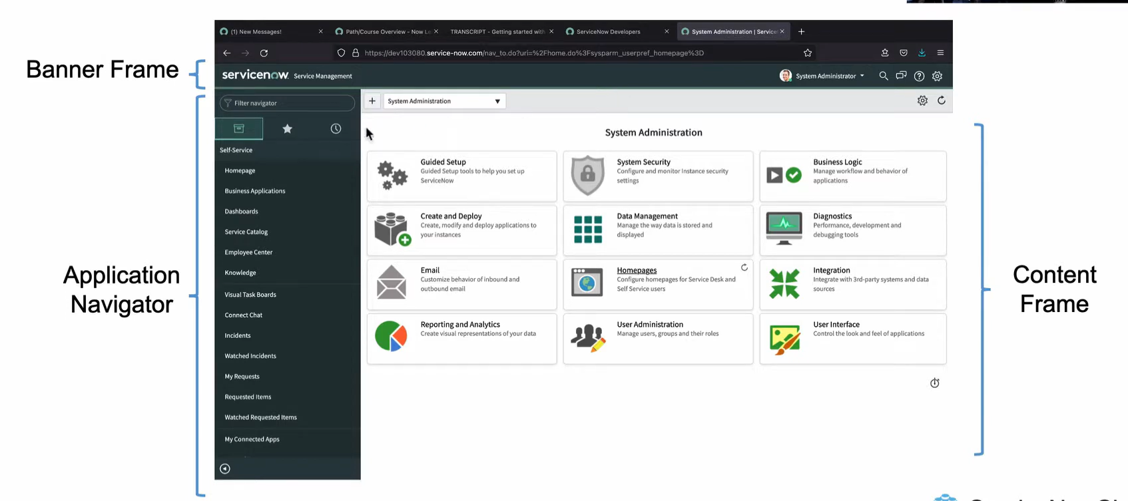

**Banner Frame: User Menu**

The User Menu provides the following tools:

Profile: Set profile attributes including name, phone, title, email, date format, time zone

Impersonate User: Access the instance as another user; available to users with admin or impersonator role

Elevate Roles: A safety mechanism for high-impact actions; available to System Admin

Logout: Logout of the ServiceNow instance

Global Search: Search the entire instance for records matching keywords

Connect Chat: ServiceNow's real-time messaging tool

Help: Displays contextual help as available; a badge on the icon indicates embedded help is available; provides access to User Guide; provides access to documentation search tool;

Banner Frame: System Settings

System Settings allows the user to customize the Ul to their preference. Settings are grouped as follows:

System Administration

General Settings

Forms Settings

Theme Settings

Notifications Settings

Accessibility Settings

Developer Settings

List Settings

**Banner Frame: System Settings (2)**

* **General Settings**

Enable/disable Compact UI

Enable/disable Keyboard shortcuts

Set Home link to Homepages or Dashboards

Set Date/Time to Calendar, Time Ago, or Both

* Theme Settings

Choose a color scheme for your Ul

Accessibility Settings

Set accessibility settings

* List Settings

Enable/disable wrapping of long text in list columns

* Form Settings

Enable/disable tabbed forms

Set related lists to load with form loading, after form loading, or on demand

* Notification Settings

Enable/disable notifications and set notification types

* Developer Settings

Select Application and Update Set

Enable/disable Application Picker and Update Set Picker

Enable/disable JavaScript Log Viewer

Enable/disable Automated Test Framework Page Inspector

**Main Screen Elements (Demo)**

1. Login to your Personal Developer Instance (PDI)

2. Locate the Application Navigator, Banner Frame, and Content Frame

3. Checkout the User Menu

1. Checkout the Profile item

2. Checkout Elevate Roles

3. Impersonate Joe Employee; note the changes

4. End Impersonation

5. Checkout the Help tool

5. Search the entire instance for 'email'

1. Note the Search Tips (information icon)

2. Notice the organization of the search results

6. Take a quick look at the Connect Chat tool

7. Checkout the System Settings options

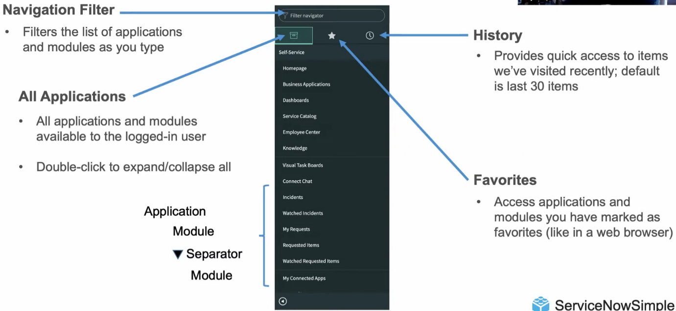

Application Navigator (Demo)

1. Login to your Personal Developer Instance (PDI)

2. Locate the three Application Navigator tabs (All Applications, Favorites, History)

3. Test out the Navigation Filter

4. Expand and collapse an Application or Section

5. Select a Module to open its content

6. Expand/collapse all Applications and Sections by double-clicking the All Applications tab

7. Mark an Application or Module as a favorite by clicking its star

8. Mark a filtered list as a favorite by dragging its breadcrumb to the Favorites list

9. Mark an individual record as a favorite by dragging it to the Favorites list

10. Access the Favorites tab to view your favorites

11. Edit a favorite via the pencil icon

12. Checkout the History tab

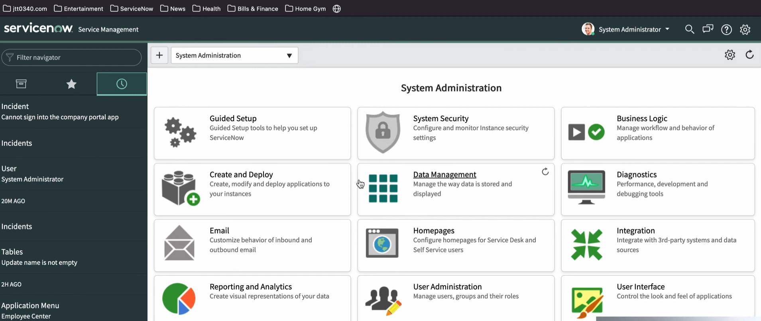

**Service Branding in ServiceNow**

What is Branding in ServiceNow?

Applying your distinct corporate identity across the Now Platform Ul to create a shared identity, build trust, and speed ad option Now Branding Introduction, Company Guided Setup, ServiceNow Portal, and UI Builder.

**Guided Setup**

* Guided Setup provides a System Administrator step-by-step instructions to configure various Applications and Modules within your instance to suit the needs of the users.
* To access Guided Setup, locate the Guided Setup application in the Application Navigator and select the ITSM Guided Setup or ITOM Guided Setup module.
* ITSM Guided Setup includes the following categories: Company, Connectivity, Foundation Data, CMDB, Incident Management, Major Incident Management, Problem Management, Change Management, Service Catalog, Knowledge Management, Continual Improvement Management, Project Communication, Go Live
* ITOM Guided Setup includes the following categories: MID Server, Discovery, Event Management, Operational Intelligence, Cloud Provisioning and Governance

**Service Portal, UI Builder**

* Service Portal and UI Builder are two additional tools that can be used to brand the interface.
* Service Portal is a widget-based tool that allows creation of intuitive, user-friendly interfaces to the Now Platform.
* UI Builder allows you to build-out a functional page by choosing from a library of components (buttons and data visualizations) and layouts.

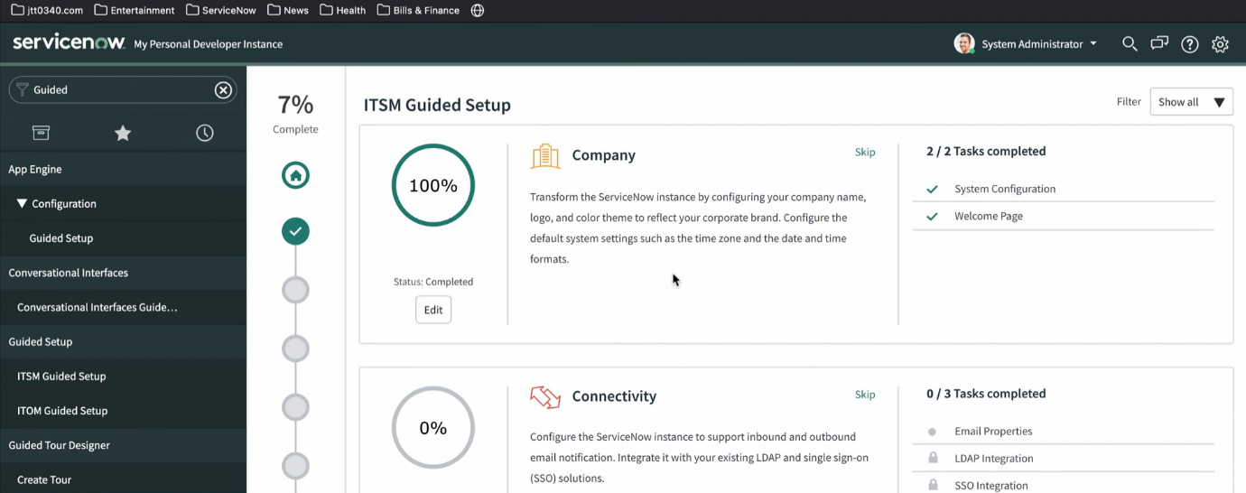

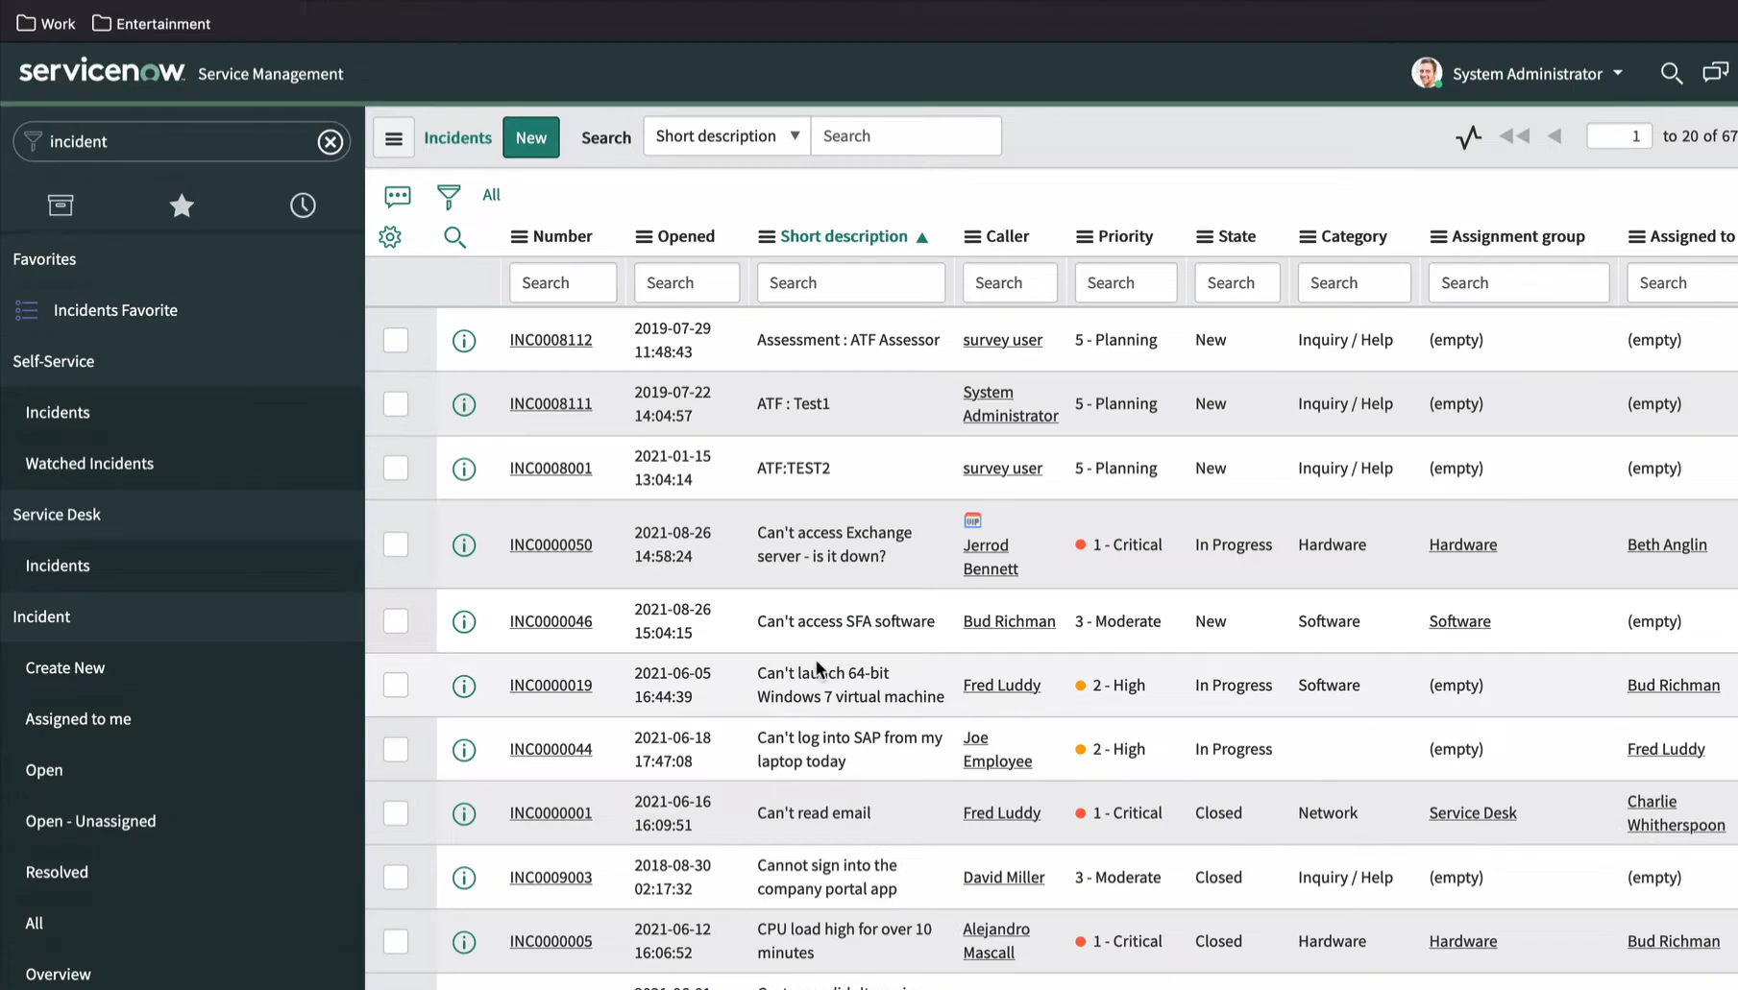

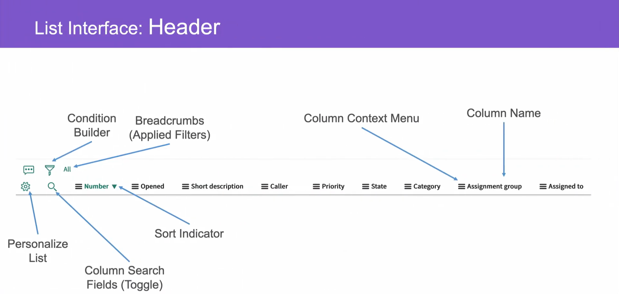

in servicenow you're going to spend a lot of time looking at lists there's lists of tables and lists of apps lists of incidents problems and tasks throughout the platform servicenow uses lists and list views to display the contents of database tables in fact there's a list view for every database in the platform there's lots of great stuff to learn from this lesson but no need to worry we're here to assist it's time to get simple with filters and lists hey it's jeff here from servicenowsimple.com where we help me to understand the ins and outs of servicenow keeping it simple all the way if you're new here we would love it if you'd subscribe to the channel just hit the subscribe button so you can get notified **Key Takeaways**

1. ServiceNow lists are a crucial part of the platform, providing a user-friendly interface to display and interact with data from database tables.
2. Lists can be accessed through the application navigator, using the ".list" command, or by navigating to a specific table.
3. The list view provides various tools for filtering, sorting, and customizing the data, including the condition builder, breadcrumbs, and context menus.
4. The condition builder allows users to create complex filters using multiple columns and operators.
5. Breadcrumbs provide a visual representation of the filters applied to the list and allow users to quickly clear or modify filters.
6. Context menus provide additional functionality, such as creating visual task boards, exporting data, and updating multiple records at once.

**ServiceNow Lists**

* Lists are a crucial part of the ServiceNow platform
* They provide a user-friendly interface to display and interact with data from database tables
* Lists can be accessed through the application navigator, using the ".list" command, or by navigating to a specific table

**List View**

* The list view provides various tools for filtering, sorting, and customizing the data
* The condition builder allows users to create complex filters using multiple columns and operators
* Breadcrumbs provide a visual representation of the filters applied to the list and allow users to quickly clear or modify filters
* Context menus provide additional functionality, such as creating visual task boards, exporting data, and updating multiple records at once

**Key Takeaways**

* ServiceNow lists are a powerful tool for working with data in the platform
* The list view provides a range of features and functionality for filtering, sorting, and customizing data
* The condition builder, breadcrumbs, and context menus are key features of the list view that can help users to work more efficiently with data in ServiceNow

**Review**

The video is well-structured and easy to follow, with the presenter providing clear explanations and examples of each topic. The use of screenshots and live demonstrations helps to illustrate the concepts and makes it easier for viewers to understand.

The video covers a wide range of topics related to ServiceNow lists, from basic concepts to more advanced features. This makes it a useful resource for both beginners and experienced users.

One minor suggestion for improvement is to provide more examples of real-world scenarios where the features and functionality described in the video would be used. This would help viewers to better understand the practical applications of the concepts being discussed.

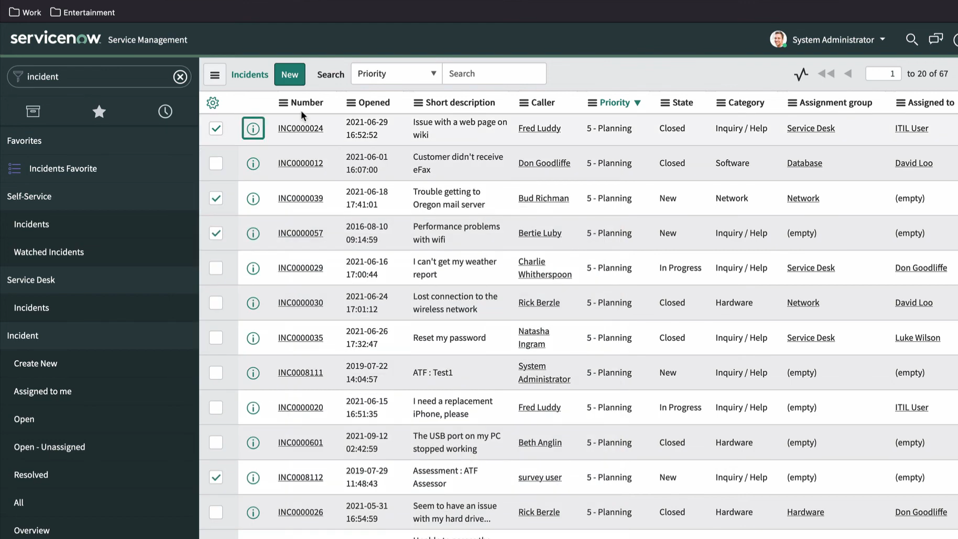

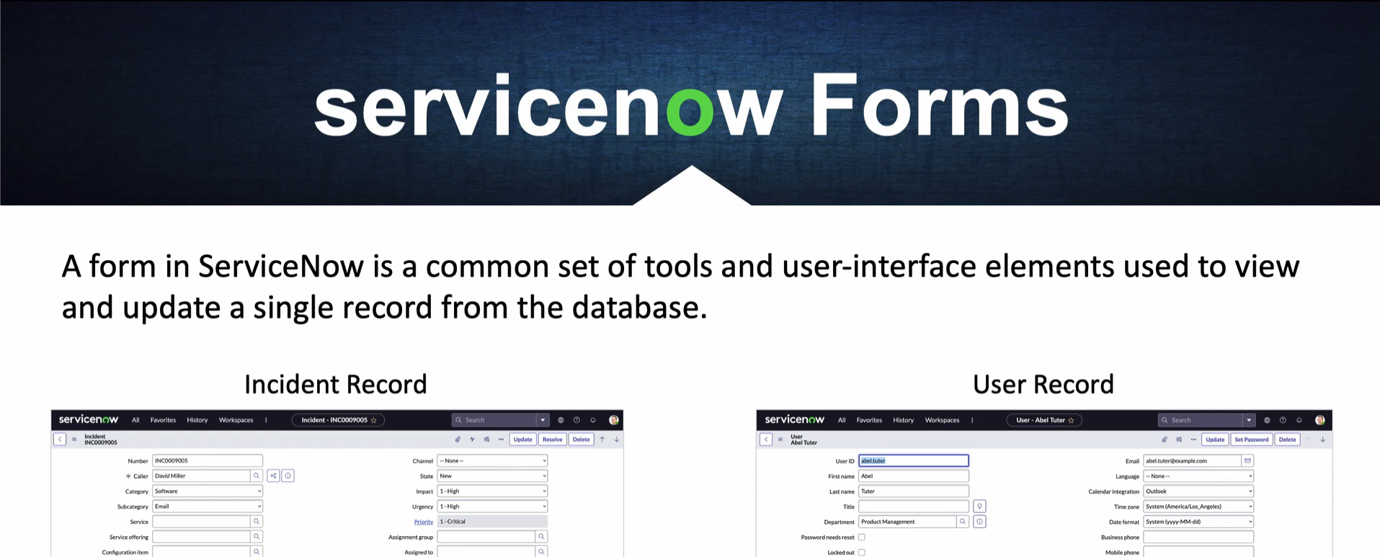

Topic is Forms, a critical component of the application's user-interface. Any time you are viewing, editing, or creating a single record in ServiceNow, you are working with a form. The lesson prepares us for the CSA Certification exam by focusing on the commonalities that exist between all ServiceNow forms including field types, standard components, saving changes, copying records, sections, related-lists, formatters, views, templates, attachments, and personalization. I took really good notes! In this series of videos, I'm reteaching all I learned from that course with a hard focus on keeping things as SIMPLE as possible.

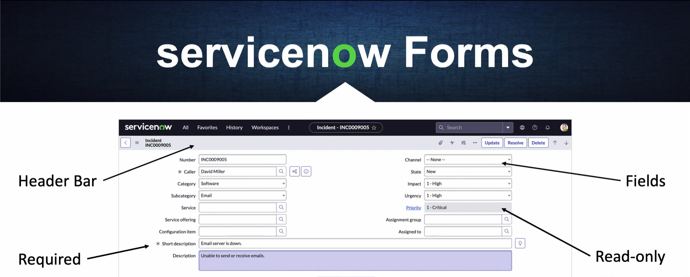

**Forms in ServiceNow**: A form in ServiceNow is a graphical user interface that displays fields from one record, allowing users to view and edit the record data. The form is the primary interface for users to interact with records in ServiceNow.

**The Standard Layout**: The standard layout is the default layout for forms in ServiceNow. It consists of a header, a body, and a footer. The header contains the form title and breadcrumbs, the body contains the form fields, and the footer contains the form buttons.

**Form Field Types**: There are several types of form fields in ServiceNow, including:

* **Text**: A single-line text field
* **Textarea**: A multi-line text field
* **Checkbox**: A checkbox field
* **Select**: A dropdown list field
* **Date**: A date field
* **DateTime**: A date and time field
* **Integer**: An integer field
* **Decimal**: A decimal field
* **Reference**: A reference field that links to another record

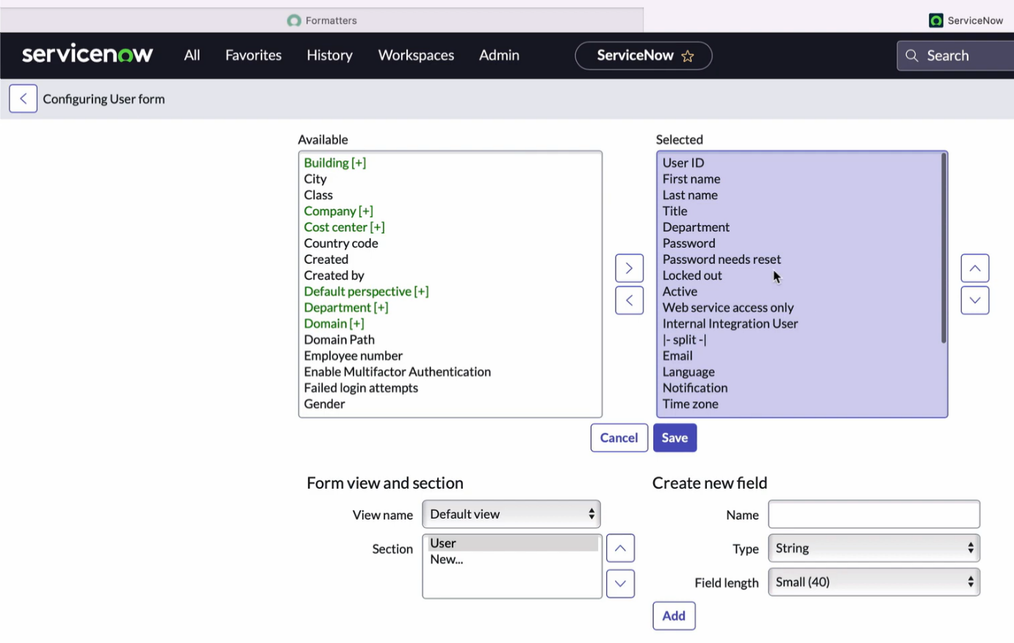

**Saving Changes**: When a user makes changes to a form, they can save their changes by clicking the **Update** button. The changes are then saved to the record.

**Insert / Insert & Stay**: When a user creates a new record, they can click the **Insert** button to save the record and return to the list of records. Alternatively, they can click the **Insert & Stay** button to save the record and remain on the form.

**Form Sections**: Form sections are used to organize form fields into logical groups. Sections can be collapsed or expanded to show or hide the fields within.

**Related Lists & Formatters**: Related lists are used to display a list of records related to the current record. Formatters are used to customize the display of related lists.

**Form Views**: Form views are used to customize the display of a form for different users or scenarios. For example, a form view can be created to display only certain fields for a specific user role.

**Form Personalization**: Form personalization allows users to customize the layout and fields of a form to suit their individual needs.

**Adding Attachments**: Attachments can be added to a form to store files related to the record.

**Form Templates**: Form templates are used to create a standard layout and design for forms. Templates can be applied to multiple forms to ensure consistency.

**Creating & Editing Views**: Views are used to customize the display of a form for different users or scenarios. Creating and editing views allows administrators to customize the form display for different use cases.

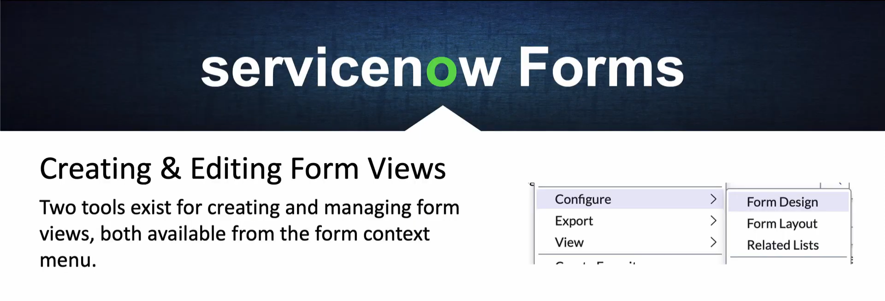

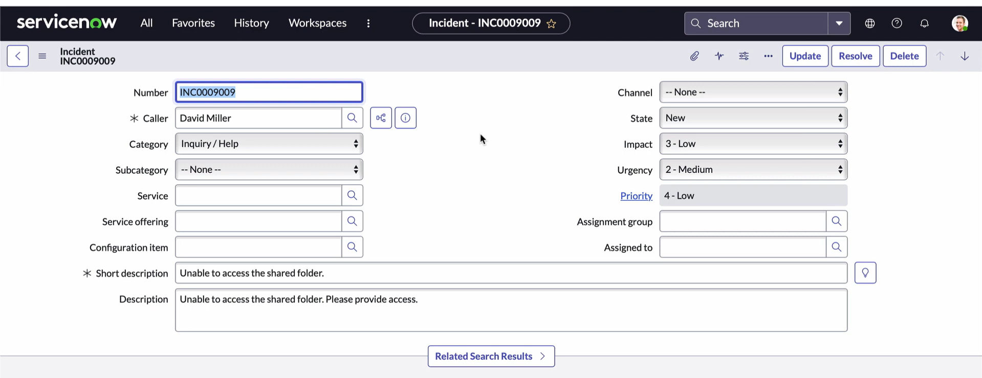

**A Hands-on ServiceNow Tool Demo:**

Logging In, ServiceNow Next Experience UI, The Navigation Bar, ServiceNow Applications Overview ,The Application Navigator, The ServiceNow Store, ServiceNow Application Training and Certifications, Working with Lists and Forms Overview, List Views, Form Views, Knowledge Management in ServiceNow, The ServiceNow Database

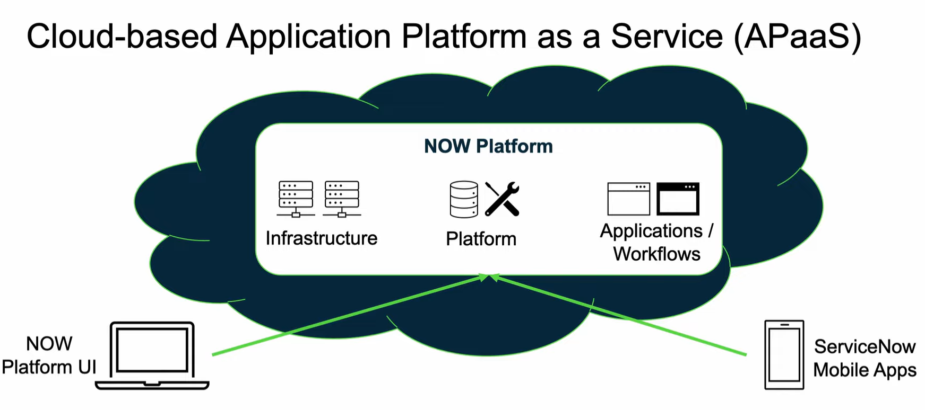

Logging In The first step in exploring ServiceNow is logging in to the platform. This involves accessing the ServiceNow instance, entering credentials, and authenticating to access the various features and functionalities.

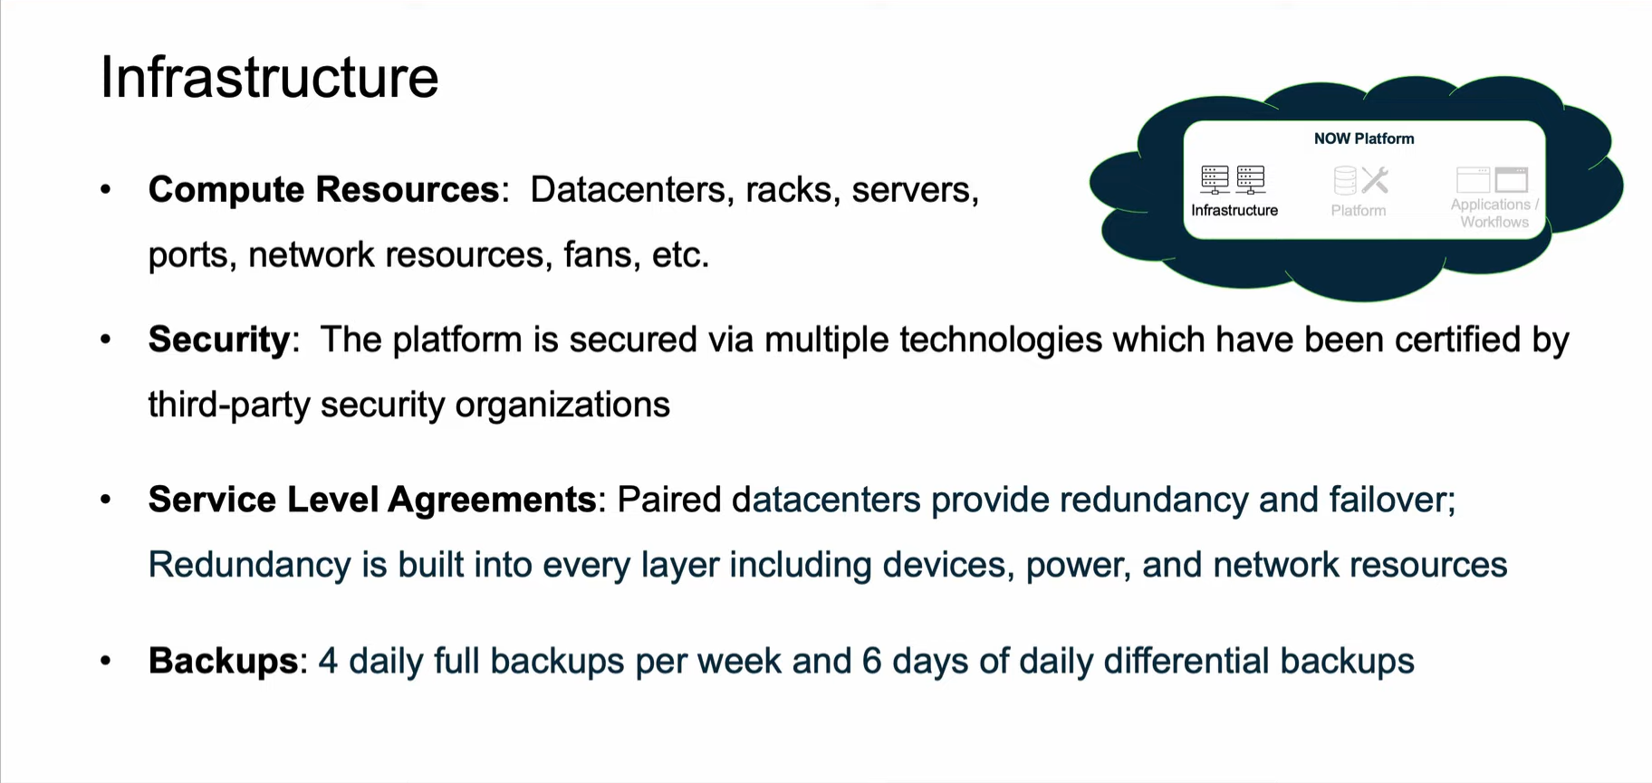

ServiceNow Next Experience UI The Next Experience UI is a modern, intuitive interface designed to provide a seamless user experience. It offers a responsive design, improved navigation, and enhanced accessibility features. The new UI is designed to simplify the user experience, making it easier to navigate and use the platform.

The Navigation Bar The Navigation Bar is a key component of the ServiceNow UI, providing quick access to various applications, modules, and features. It's customizable, allowing administrators to tailor the navigation to meet specific business needs.

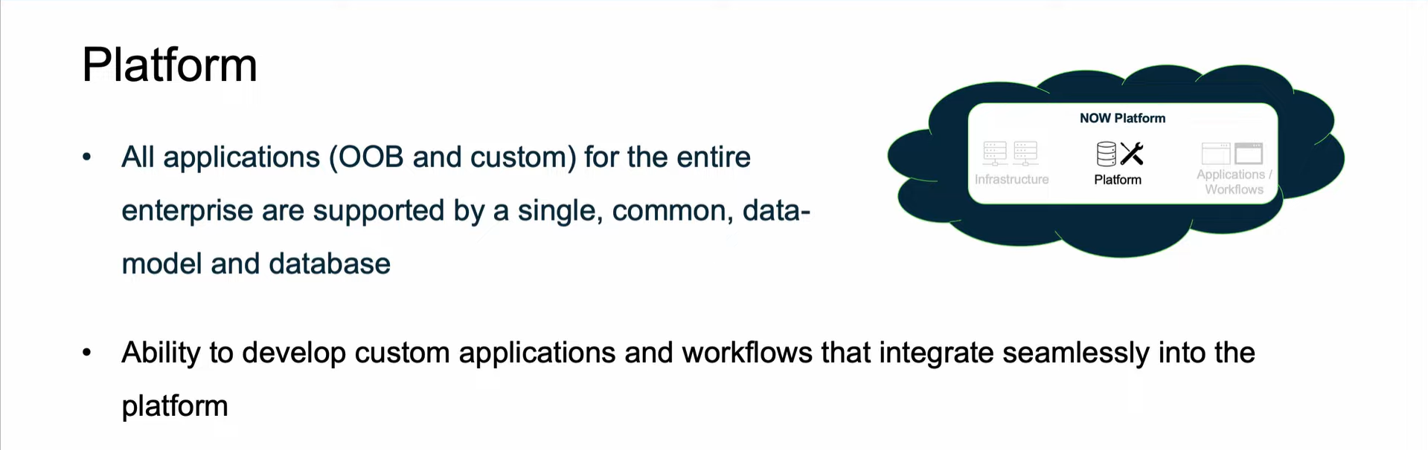

ServiceNow Applications Overview ServiceNow offers a wide range of applications, including IT Service Management (ITSM), Customer Service Management (CSM), Security Operations, and more. These applications are designed to automate and streamline various business processes, improving efficiency and productivity.

The Application Navigator The Application Navigator is a feature that allows users to easily discover and access various ServiceNow applications. It provides a centralized location to browse and launch applications, making it easier to find the tools and features needed to perform specific tasks.

The ServiceNow Store The ServiceNow Store is a marketplace that offers a wide range of certified applications, integrations, and plugins. These solutions can be easily downloaded and installed to extend the capabilities of the ServiceNow platform.

ServiceNow Application Training and Certifications ServiceNow provides various training and certification programs to help users develop the skills needed to effectively use the platform. These programs cover various aspects of ServiceNow, including administration, development, and application-specific training.

Working with Lists and Forms Overview Lists and forms are fundamental components of ServiceNow, used to store and manage data. Lists provide a way to display and manipulate data, while forms are used to create and edit records.

List Views List views are used to display data in a tabular format, making it easy to view and manipulate large datasets. List views can be customized to meet specific business needs, including filtering, sorting, and grouping data.

Form Views Form views are used to create and edit records, providing a structured way to capture and display data. Form views can be customized to meet specific business needs, including adding custom fields, sections, and business rules.

Knowledge Management in ServiceNow Knowledge Management is a feature in ServiceNow that enables organizations to capture, store, and share knowledge across the enterprise. It provides a centralized repository for storing and managing knowledge articles, making it easier to find and reuse existing knowledge.

The ServiceNow Database The ServiceNow database is a powerful data repository that stores all data and metadata for the platform. It's designed to provide high performance, scalability, and reliability, making it an ideal choice for large-scale enterprise deployments.

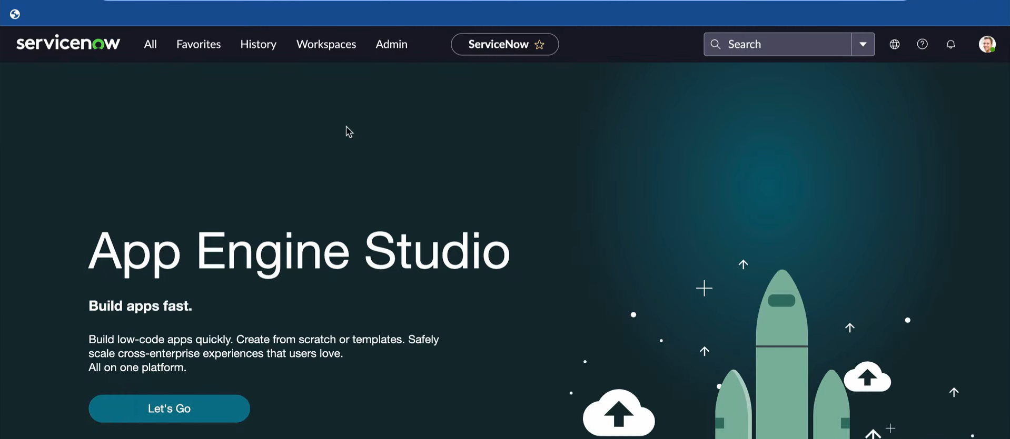

* ServiceNow is a powerful platform that offers a modern, intuitive interface and a wide range of applications to automate and streamline various business processes.
* The platform provides a high degree of customization, allowing administrators to tailor the navigation, lists, forms, and other features to meet specific business needs.
* The ServiceNow Store offers a wide range of certified applications, integrations, and plugins to extend the capabilities of the platform.
* The platform provides robust knowledge management capabilities, enabling organizations to capture, store, and share knowledge across the enterprise.
* The ServiceNow database is a powerful data repository that stores all data and metadata for the platform, providing high performance, scalability, and reliability.

**Creating a Data Source in ServiceNow:**

Integrations in ServiceNow start with the creation of a Data Source, creating a Data Source record in ServiceNow to load data from some external data, collection and importing into the ServiceNow platform.

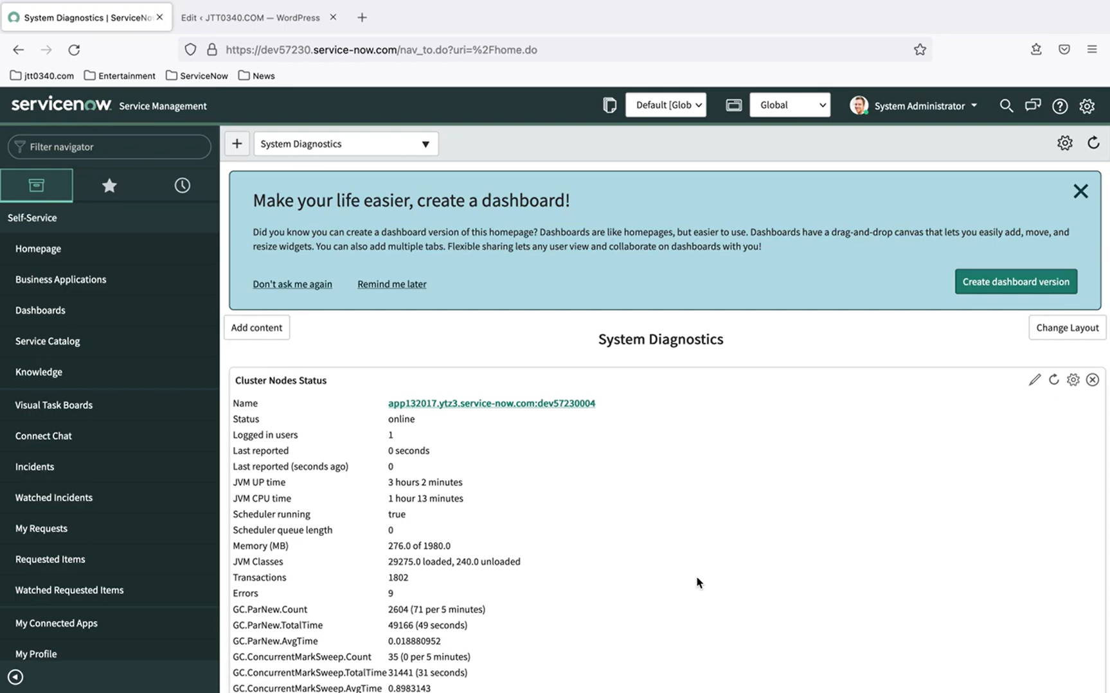

Creating a Data Source Record

To create a Data Source record in ServiceNow, follow these steps:

* Navigate to the Data Sources module in your ServiceNow instance.
* Click New to create a new Data Source record.
* Fill in the required fields, such as Name, Description, and Data Source Type.
* Configure the Connection settings, depending on the type of external system you are connecting to.
* Define the Data Format, specifying the structure and format of the incoming data.
* Click Submit to save the Data Source record.

Data Source Types

ServiceNow supports various Data Source types, including:

* Database: Connect to a relational database, such as MySQL or Oracle.
* File: Import data from a file, such as a CSV or JSON file.
* Web Service: Connect to a web service, such as a RESTful API.
* Message Queue: Import data from a message queue, such as RabbitMQ or Apache Kafka.

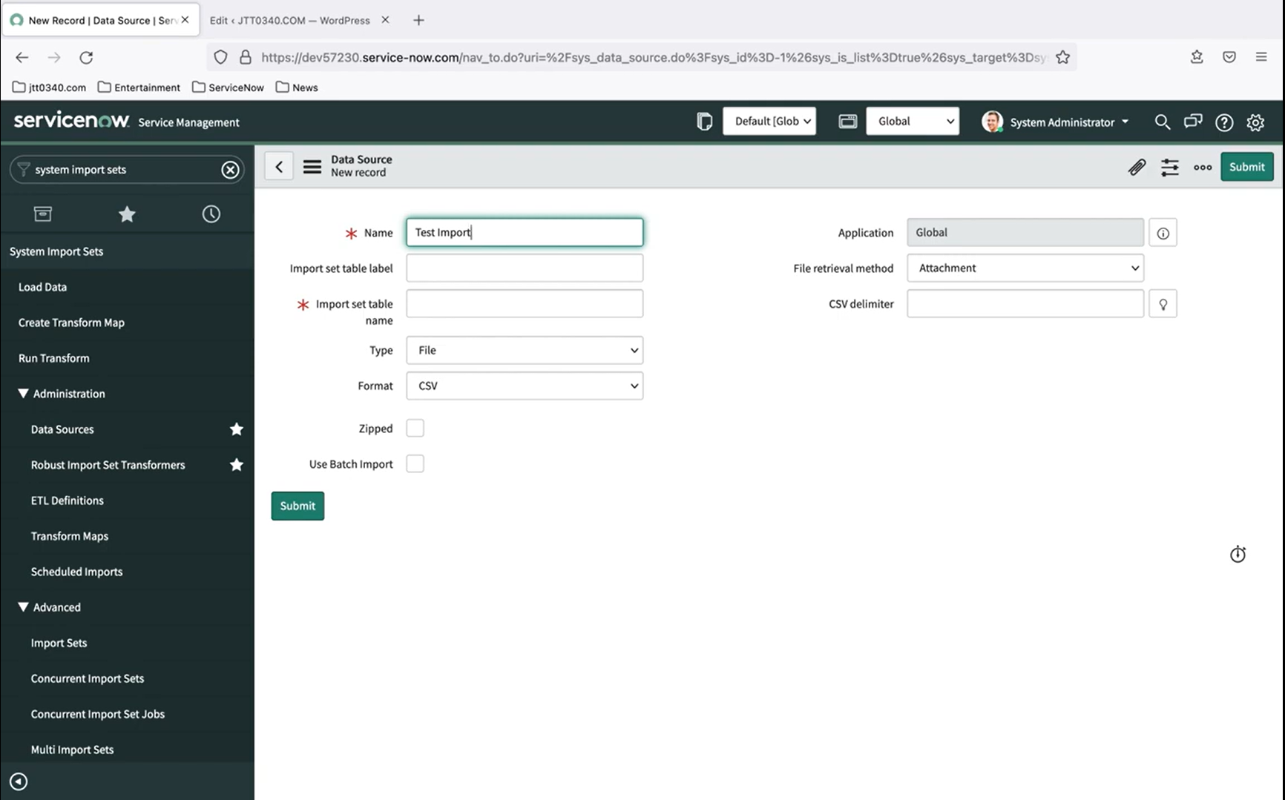

Benefits of Creating a Data Source

Creating a Data Source in ServiceNow provides several benefits, including:

Centralized data management: Consolidate data from multiple external systems into a single platform.

Improved data accuracy: Ensure data consistency and accuracy by defining a standardized data format.

Enhanced reporting and analytics: Leverage imported data to generate reports and perform analytics.

Define the Data Source: Create a Data Source record in ServiceNow to define what data an import set should import.

Choose the Data Source Type: Select the type of data source, such as a database, file, web service, or message queue.

Configure the Connection: Set up the connection to the external system, including the URL, credentials, and other settings.

Define the Data Format: Specify the structure and format of the incoming data, such as CSV, JSON, or XML.

Test the Connection: Verify that the connection to the external system is successful and data can be imported.

Create an Import Set: Use the Data Source to create an import set, which defines how the data should be imported and transformed . Schedule the Import: Set up a schedule to import the data at regular intervals, such as daily or weekly.

**Understanding Import Sets in Service Now :**

How import sets are created and how they provide the ability to transform data and map individual fields to target tables.

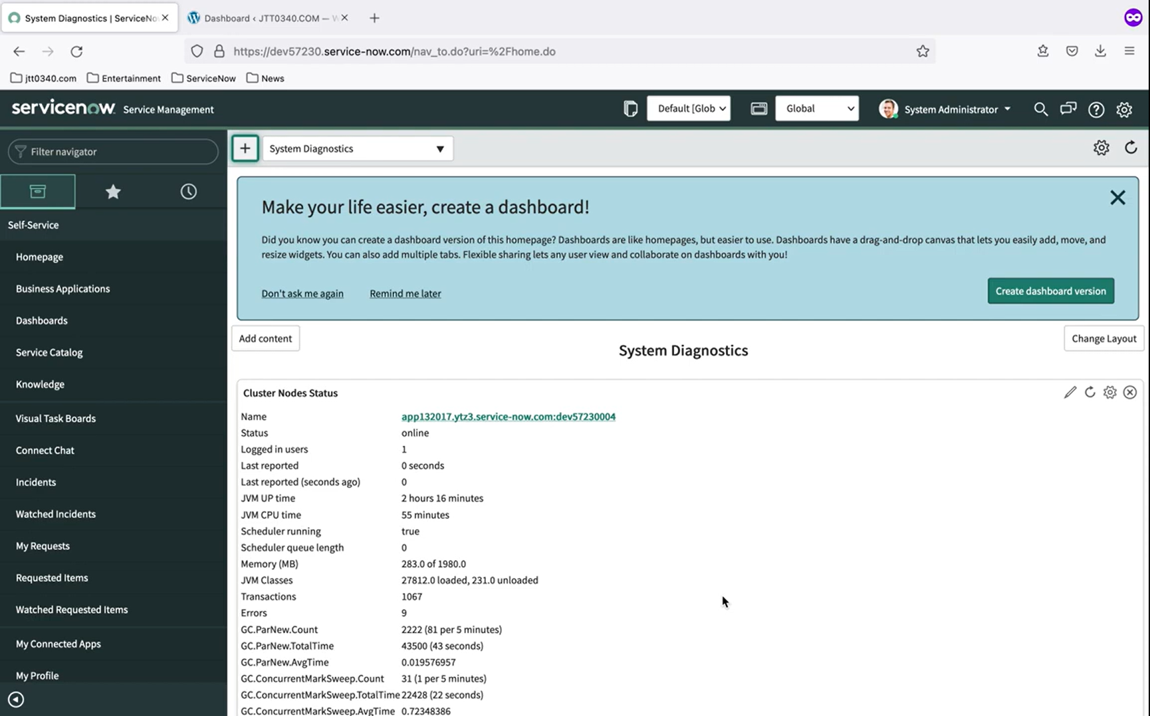

**Creating Import Sets**

To create an Import Set in ServiceNow, follow these steps:

1. **Navigate to the Import Sets module**: Go to **System Import Sets** > **Import Sets**.
2. **Click on New**: Click on the **New** button to create a new Import Set.
3. **Choose a data source**: Select the data source type (e.g., CSV, Excel, JSON, etc.) and provide the necessary connection details.
4. **Define the import set**: Provide a name and description for the Import Set, and specify the target table in ServiceNow where the data will be imported.
5. **Configure the import**: Choose the import method (e.g., append, update, or delete) and set any additional import options.

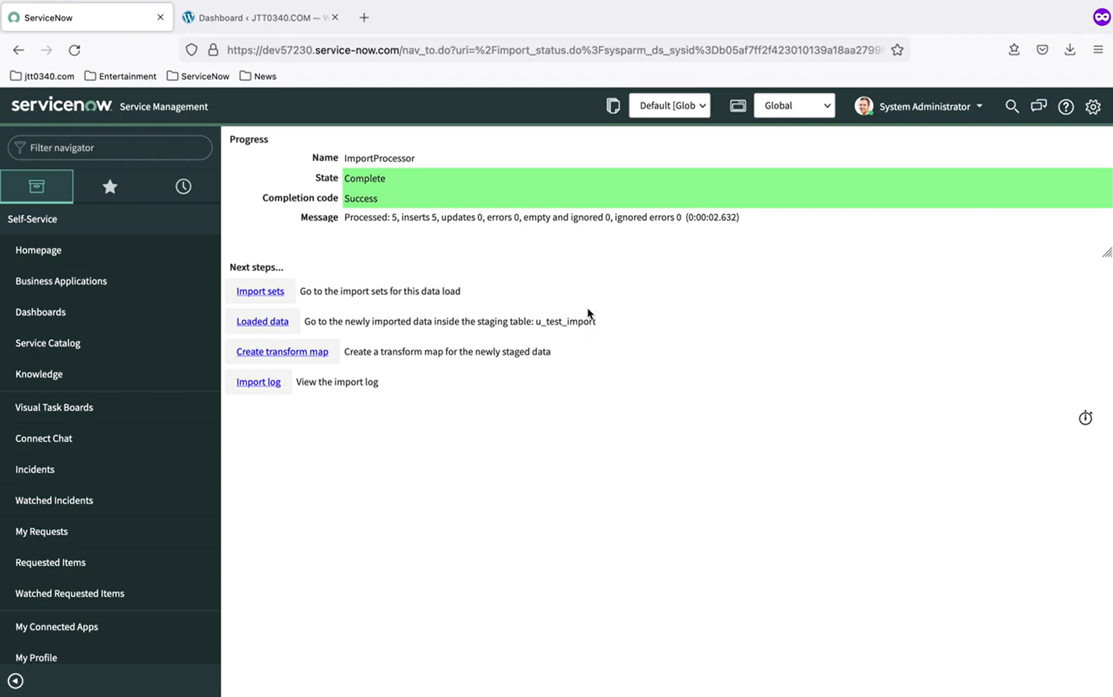

**Transforming Data and Mapping Fields**

One of the key benefits of Import Sets is the ability to transform and map data from the external source to the target table in ServiceNow. This is achieved through the use of **Transform Maps**.

A Transform Map is a set of rules that define how to transform and map the data from the external source to the target table. Transform Maps can be used to:

* **Rename fields**: Map fields from the external source to fields in the target table.
* **Perform data transformations**: Apply transformations to the data, such as converting data types or performing calculations.
* **Filter data**: Filter out unwanted data or apply conditional logic to the import process.

To create a Transform Map, follow these steps:

1. **Navigate to the Transform Maps module**: Go to **System Import Sets** > **Transform Maps**.
2. **Click on New**: Click on the **New** button to create a new Transform Map.
3. **Define the transform map**: Provide a name and description for the Transform Map, and specify the source and target fields.
4. **Configure the transform rules**: Define the transform rules using a drag-and-drop interface or by writing scripts.

**Benefits of Import Sets**

Import Sets provide several benefits, including:

* **Flexibility**: Import Sets can be used to import data from a wide range of sources, including CSV, Excel, JSON, and more.
* **Data transformation**: Import Sets enable data transformation and mapping, making it easy to integrate data from external sources into ServiceNow.
* **Automation**: Import Sets can be scheduled to run automatically, making it easy to keep data in sync between systems.

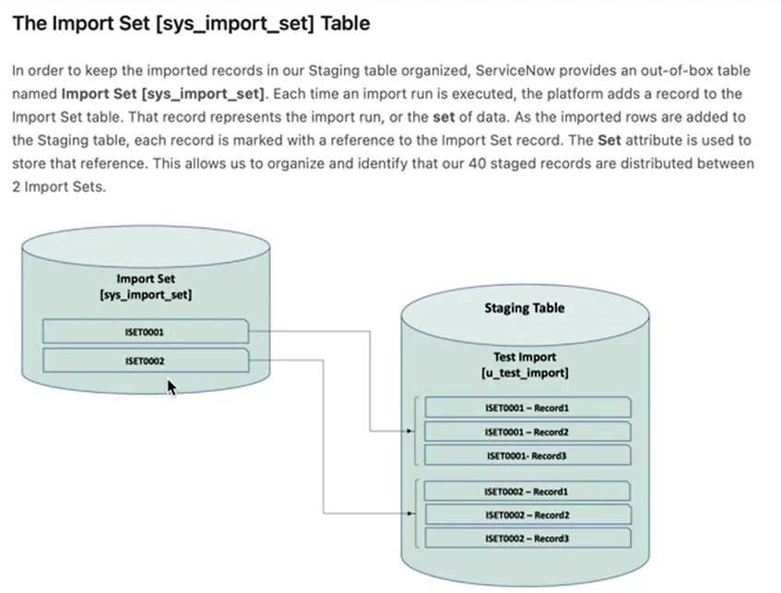

Incident Management Capabilities

* Incident Creation: Automatic incident creation through various channels such as email, phone, and self-service portal.
* Task Creation: Creation of tasks to resolve incidents, including assignment of tasks to individuals or groups.
* Task Assignment Rules: Definition of rules to automate task assignment based on factors such as incident category, priority, and location.
* Task Collaboration: Collaboration features to facilitate communication and coordination among team members.
* Visual Task Boards: Visualization of tasks and incidents using Kanban boards, providing a clear view of the workflow and enabling efficient tracking and management.

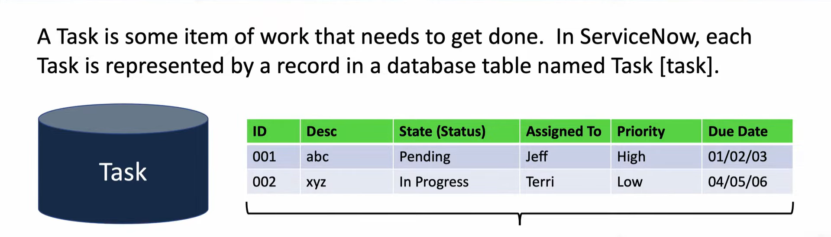

ServiceNow's incident management capabilities are closely integrated with other modules, including Problem and Change Management.

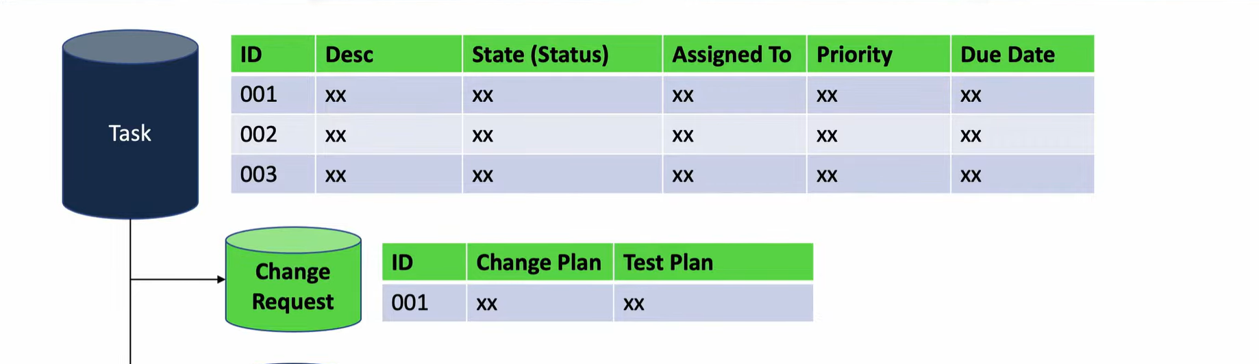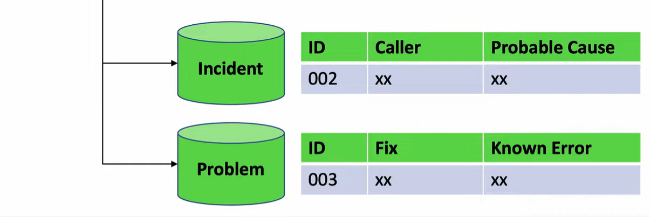

Problem Management

Problem management involves identifying the root cause of incidents and implementing permanent solutions to prevent future occurrences. ServiceNow's problem management capabilities include:

* Problem Identification: Identification of problems through incident analysis and pattern recognition.
* Root Cause Analysis: Performance of root cause analysis to identify the underlying cause of problems.
* Solution Implementation: Implementation of solutions to prevent future occurrences of incidents.  
  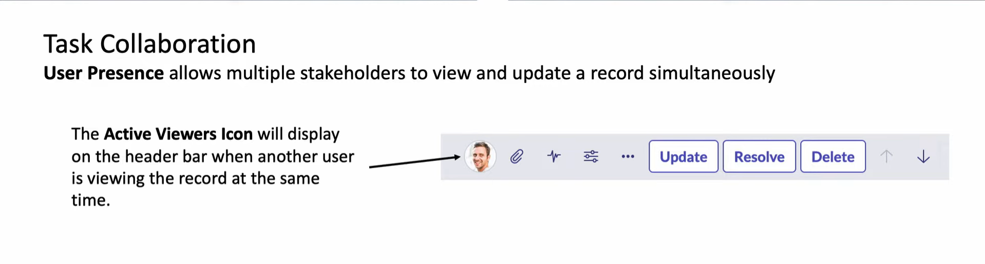

Change Management

Change management involves managing changes to the IT infrastructure to minimize disruptions and ensure that changes are properly assessed, approved, and implemented. ServiceNow's change management capabilities include:

* Change Request Management: Management of change requests, including assessment, approval, and implementation.
* Change Scheduling: Scheduling of changes to minimize disruptions and ensure that changes are implemented during planned maintenance windows.
* Change Review and Approval: Review and approval of changes to ensure that they meet business requirements and do not introduce unnecessary risks.

ServiceNow Reporting Tutorial :

ServiceNow's reporting capabilities, the different types of reports, how to create and manage reports, and how to share reports with users, groups, or via dashboards.

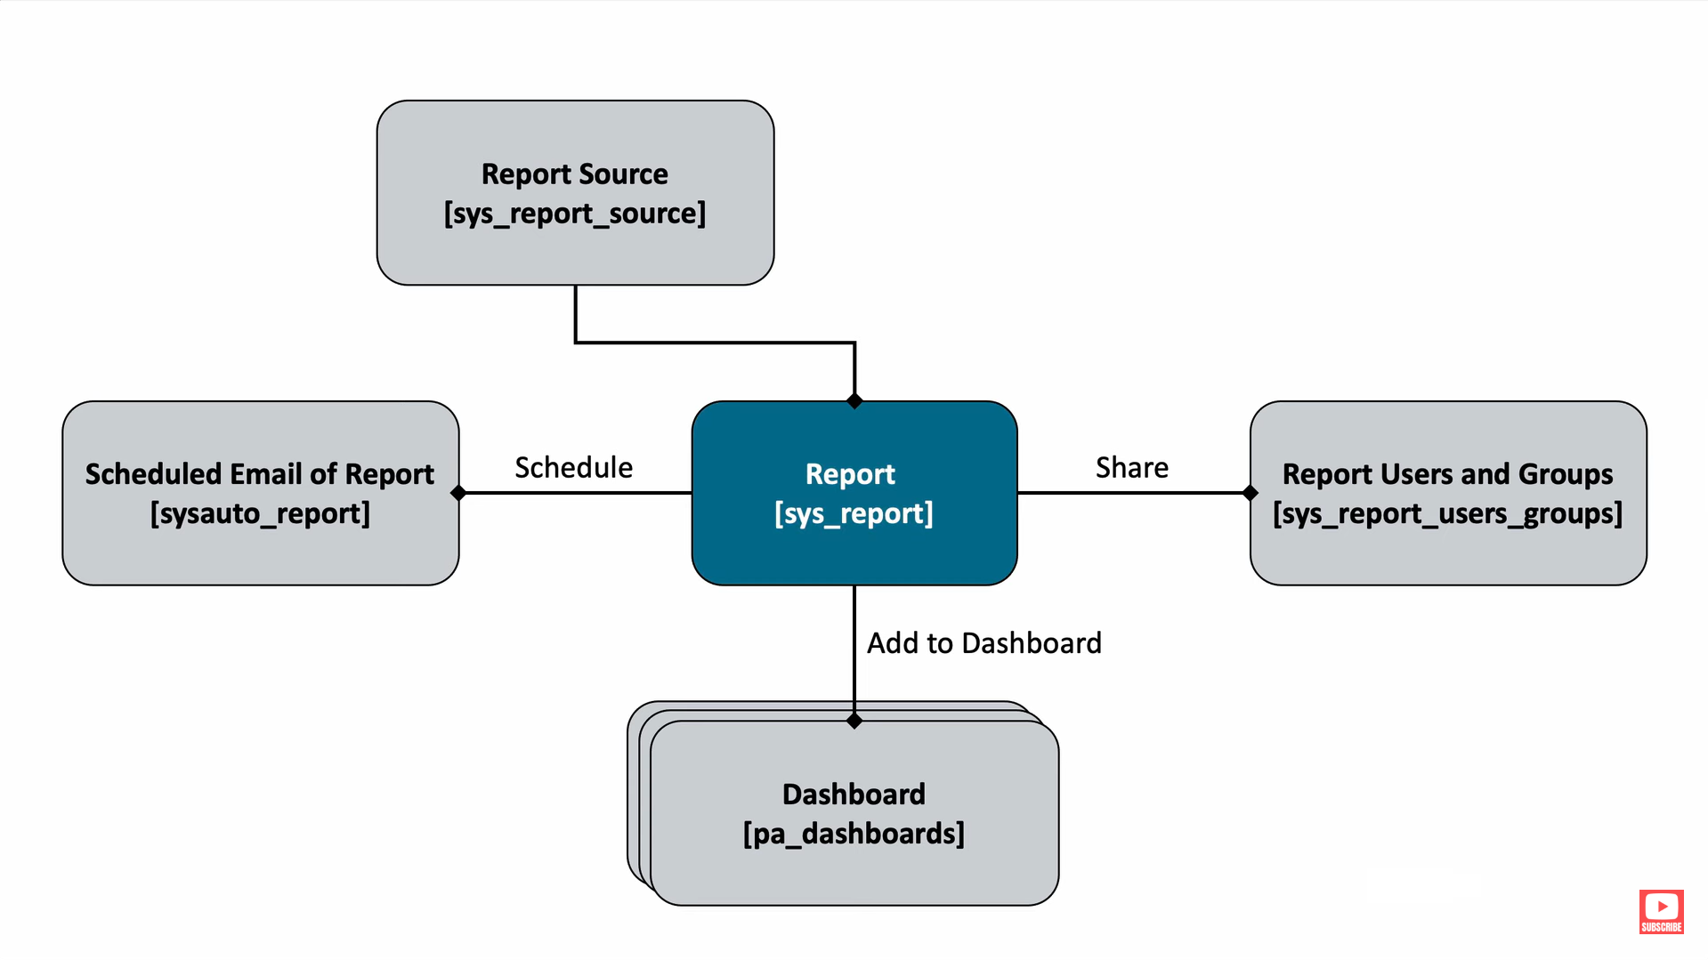

**ServiceNow Reporting Capabilities**

ServiceNow's reporting capabilities allow users to extract insights from their data, track key performance indicators (KPIs), and identify areas for improvement. The platform offers a range of reporting features, including:

1. **Ad-hoc reporting**: Create custom reports on the fly using a drag-and-drop interface.
2. **Scheduled reporting**: Automate report generation and distribution to stakeholders.
3. **Real-time reporting**: Get instant insights into your data with real-time reports.
4. **Data analytics**: Leverage advanced analytics and machine learning algorithms to uncover hidden trends and patterns.

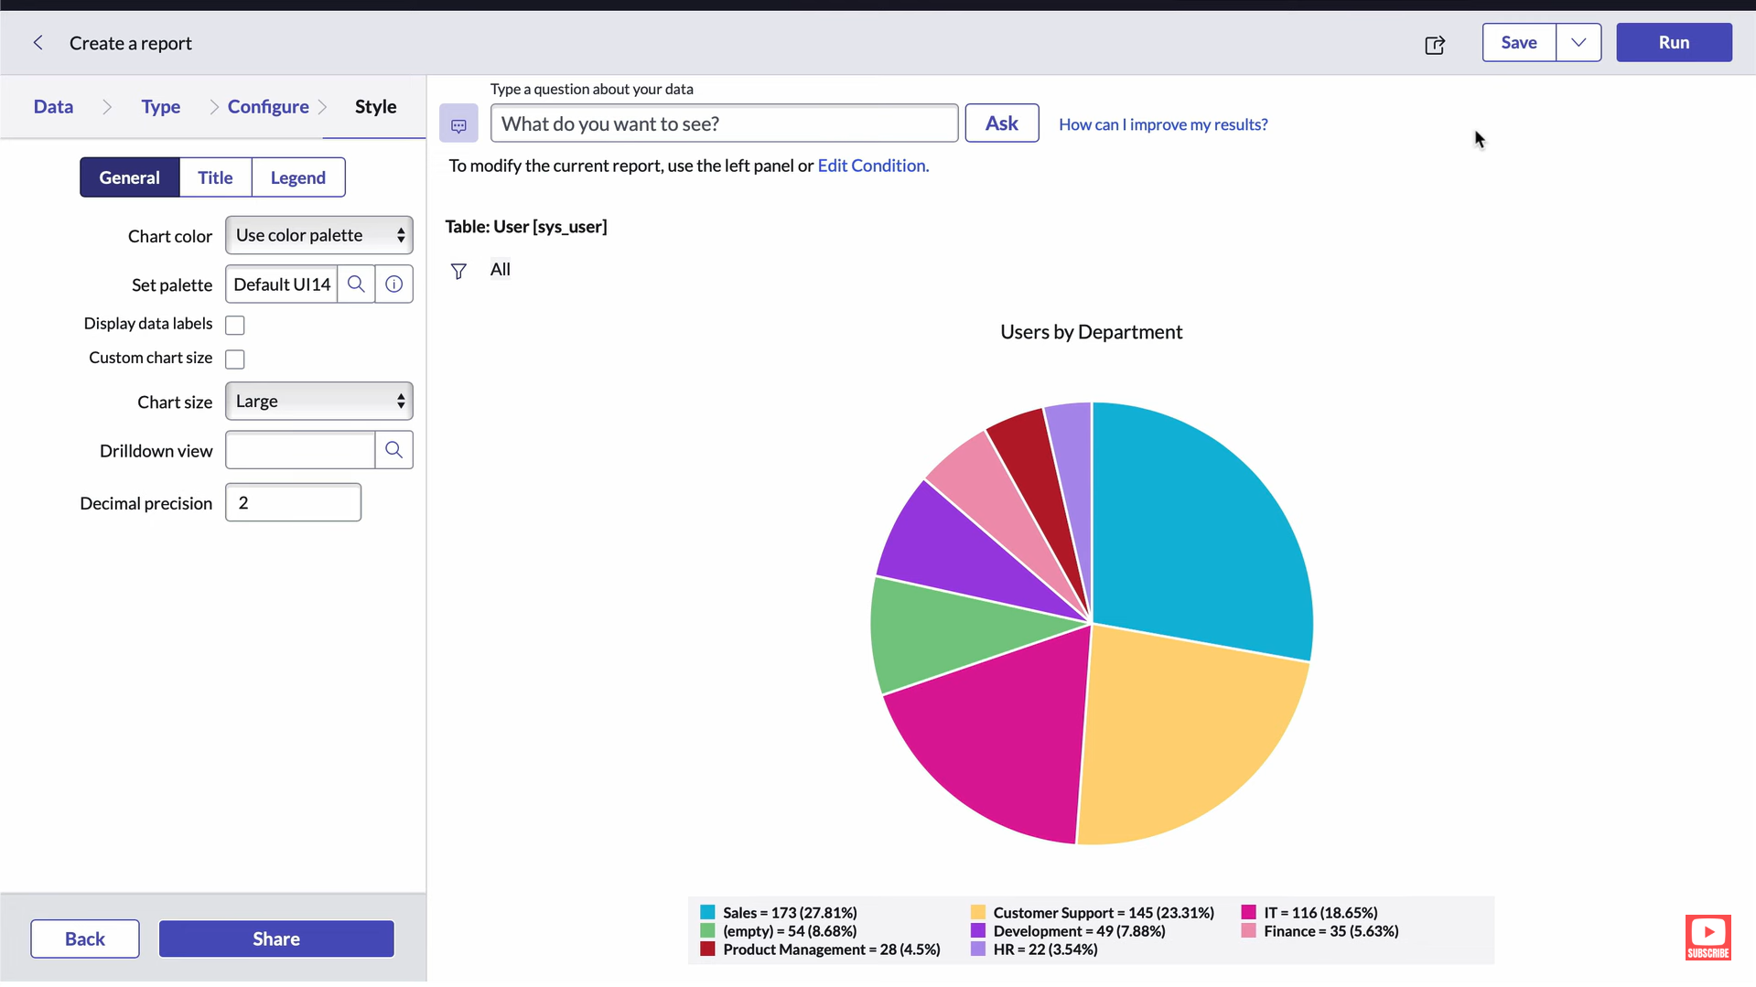

**Types of Reports in ServiceNow**

ServiceNow offers various types of reports to cater to different business needs:

1. **List reports**: Display data in a tabular format, ideal for tracking inventory, incidents, or changes.
2. **Scorecard reports**: Visualize KPIs and metrics using gauges, charts, and graphs.
3. **Summary reports**: Aggregate data to provide a high-level overview of performance metrics.
4. **Detail reports**: Drill down into specific data points to analyze trends and patterns.
5. **Calendar reports**: Display data in a calendar format, useful for tracking schedules and deadlines.

**Creating Reports in ServiceNow**

To create a report in ServiceNow, follow these steps:

1. **Navigate to the Reports module**: Access the Reports module from the ServiceNow navigation menu.
2. **Choose a report type**: Select the type of report you want to create (e.g., list, scorecard, summary, detail, or calendar).
3. **Define the report criteria**: Specify the data you want to include in the report, such as tables, fields, and filters.
4. **Configure the report layout**: Customize the report layout, including columns, rows, and formatting.
5. **Save and run the report**: Save the report and run it to generate the output.

**Managing Reports in ServiceNow**

To manage reports in ServiceNow, you can:

1. **Organize reports into folders**: Create folders to categorize and store reports.
2. **Set report permissions**: Control who can view, edit, or delete reports.
3. **Schedule report updates**: Automate report updates to ensure data freshness.
4. **Archive reports**: Store historical reports for future reference.

**Sharing Reports in ServiceNow**

ServiceNow offers several ways to share reports with users, groups, or via dashboards:

1. **Share reports with users**: Assign reports to individual users or groups.
2. **Embed reports in dashboards**: Add reports to custom dashboards for a unified view.
3. **Export reports**: Export reports in various formats (e.g., PDF, CSV, Excel) for external sharing.
4. **Create report subscriptions**: Allow users to subscribe to reports and receive automated updates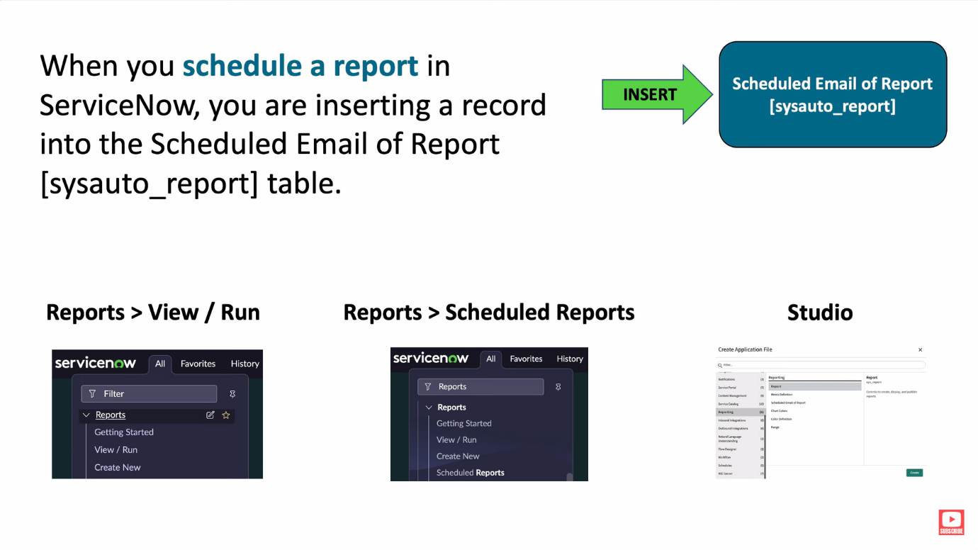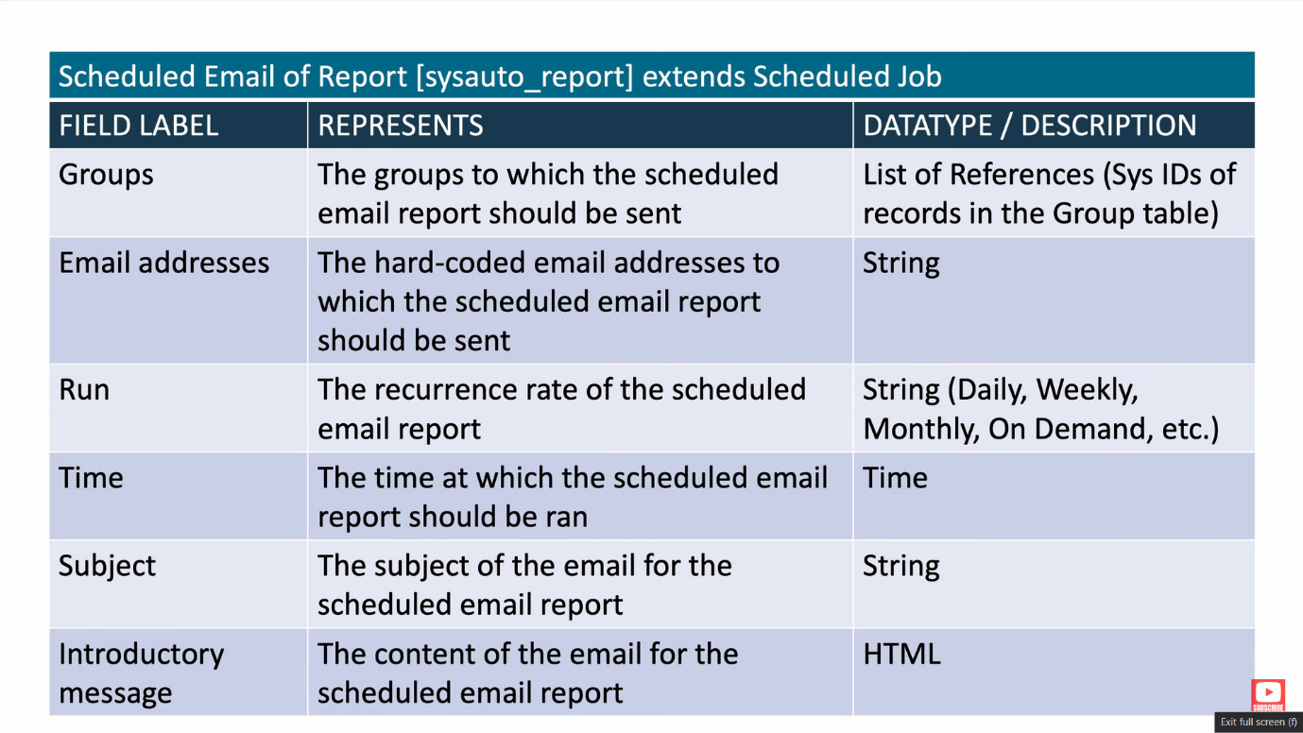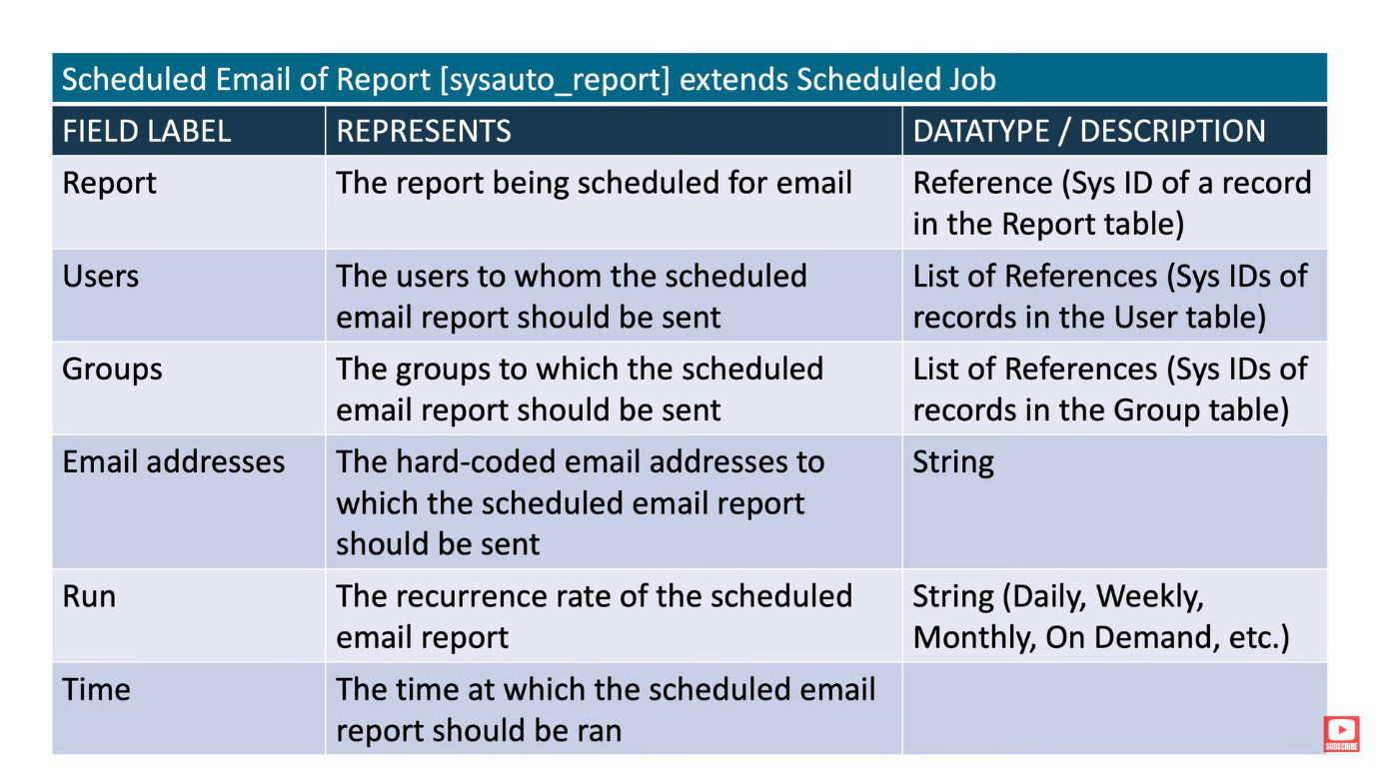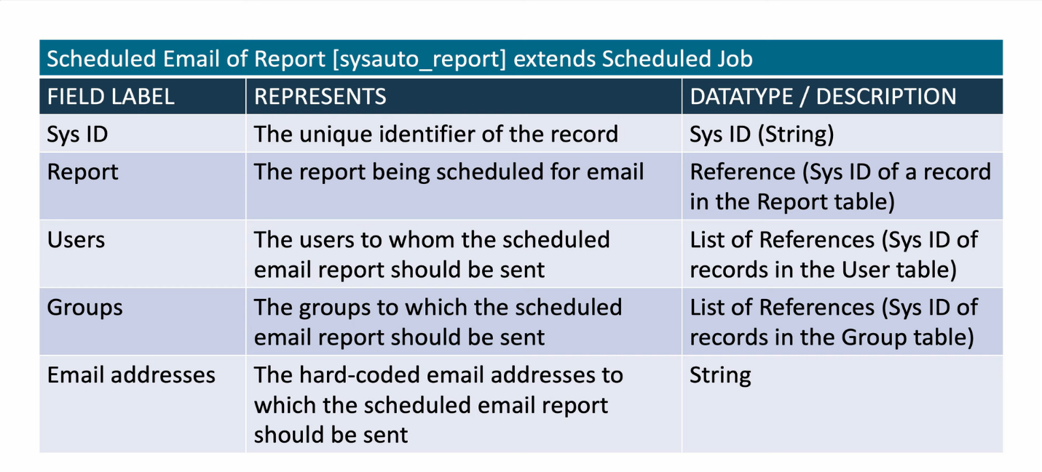

Introduction to Importing Data in ServiceNow

ServiceNow provides various ways to import data into its platform, enabling users to leverage external data sources to enhance their ServiceNow experience. One of the primary methods of importing data is through integrations.

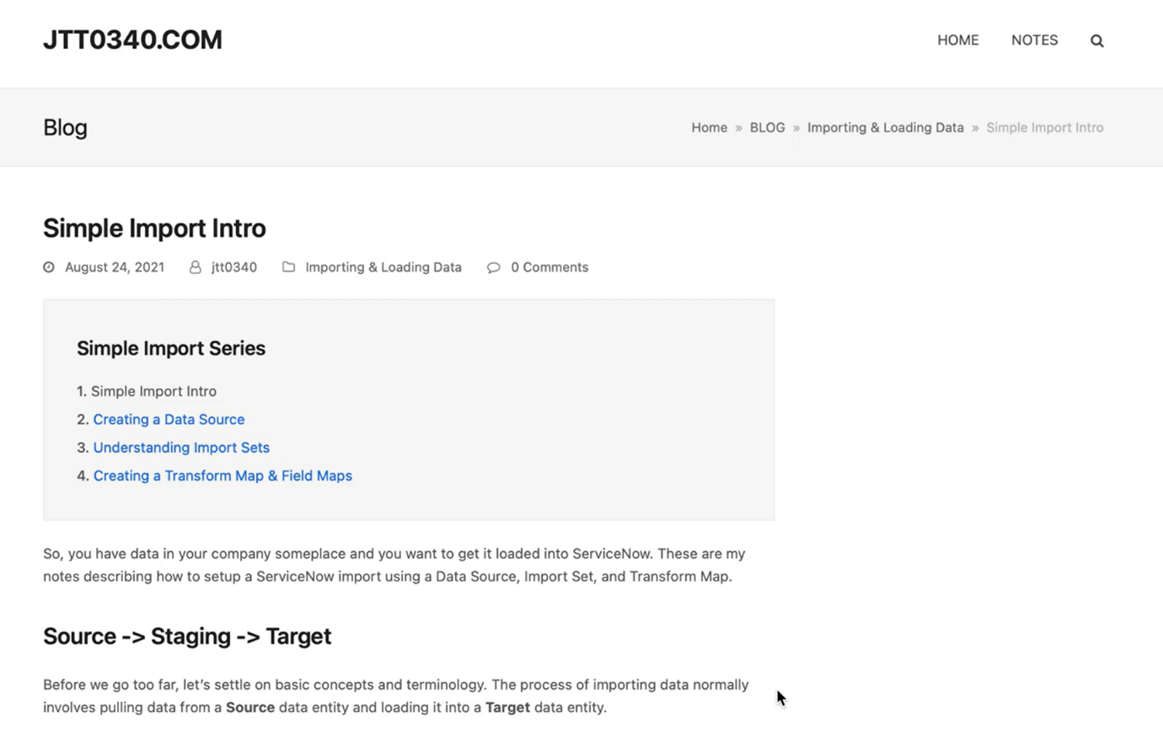

Importing Data via Integrations

Integrations in ServiceNow allow users to connect to external systems, services, or applications and import data into ServiceNow. This imported data can then be used to create new records, update existing records, or synchronize data between systems.

Types of Integrations

ServiceNow supports various types of integrations, including:

1. Web Services: Import data from web services using SOAP, REST, or JSON.
2. File Imports: Import data from files, such as CSV, Excel, or XML.
3. Database Imports: Import data directly from external databases, such as MySQL or Oracle.
4. API Integrations: Import data using APIs from external services, such as Salesforce or Google Drive.

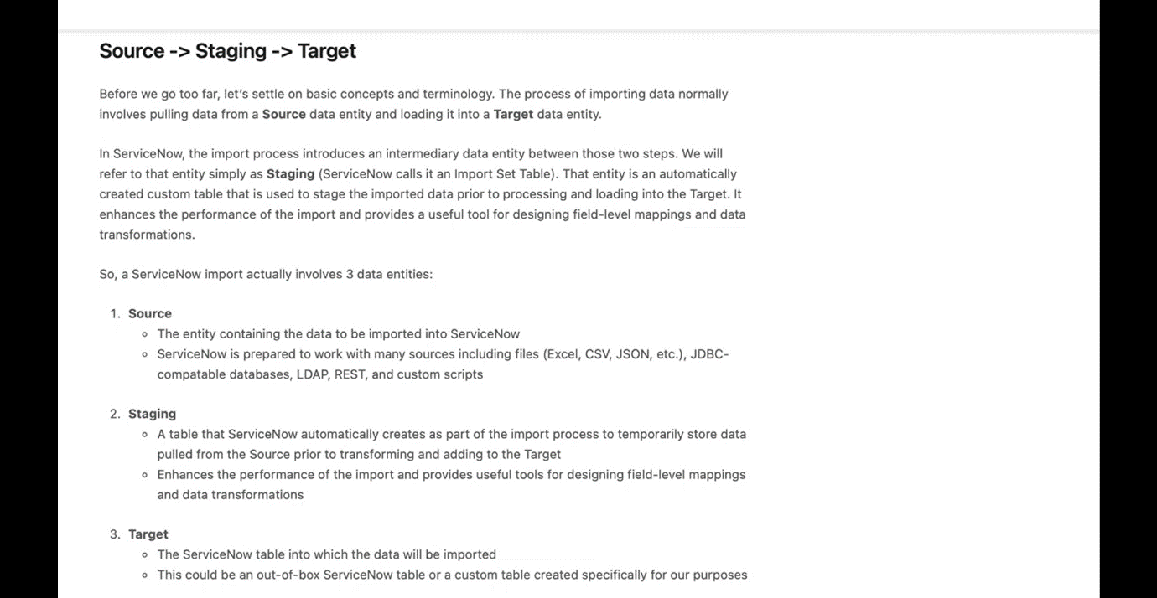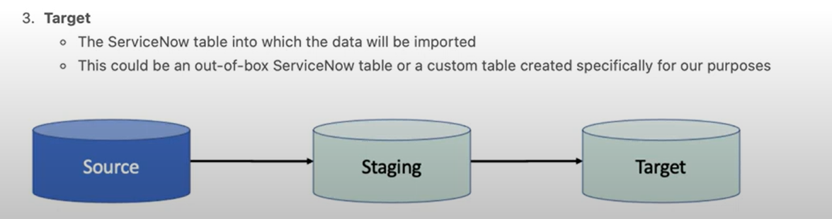

Benefits of Importing Data via Integrations

Importing data via integrations offers several benefits, including:

1. Automated Data Synchronization: Automatically synchronize data between systems, reducing manual data entry and errors.
2. Improved Data Accuracy: Ensure data consistency and accuracy by importing data from trusted sources.
3. Enhanced Reporting and Analytics: Leverage imported data to create comprehensive reports and analytics.
4. Increased Productivity: Automate data import processes, freeing up staff to focus on higher-value tasks.

Configuring Integrations in ServiceNow

To configure integrations in ServiceNow, follow these general steps:

1. Create an Integration: Create a new integration in ServiceNow, selecting the type of integration and external system or service.
2. Configure Connection: Configure the connection to the external system or service, including authentication and data mapping.
3. Define Import Rules: Define rules for importing data, including data filtering, transformation, and validation.
4. Test and Deploy: Test the integration and deploy it to production.

Best Practices for Importing Data via Integrations

To ensure successful data imports, follow these best practices:

1. Plan and Test Thoroughly: Plan and test integrations thoroughly to ensure data accuracy and integrity.
2. Monitor and Maintain: Monitor and maintain integrations regularly to ensure data synchronization and troubleshoot issues.
3. Use Data Validation: Use data validation to ensure imported data meets ServiceNow's data quality standards.
4. Document Integrations: Document integrations and data imports for future reference and troubleshooting.

**ServiceNow Transform Maps & Field Maps :**

Importing, transforming, and mapping imported data into ServiceNow

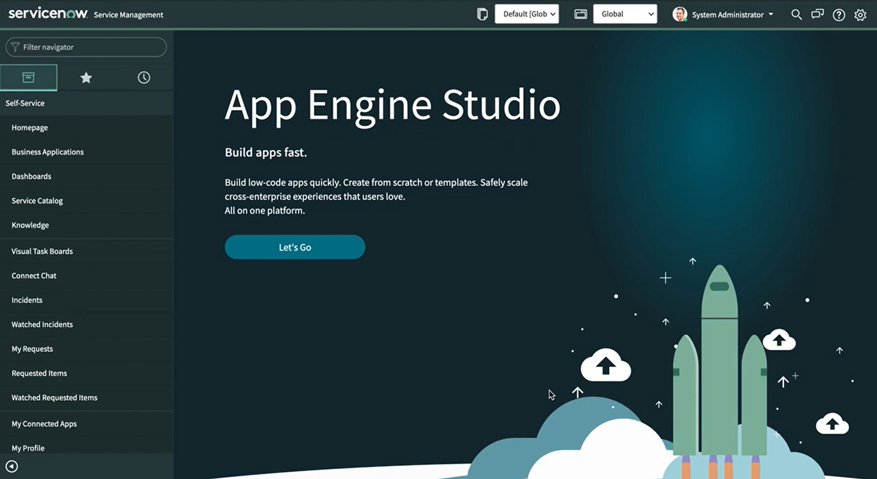

**Transform Maps**

A Transform Map is a powerful tool in ServiceNow that allows you to transform and manipulate imported data from external sources, such as CSV files, web services, or other data sources. The primary purpose of a Transform Map is to convert the incoming data into a format that can be easily consumed by ServiceNow.

Here are some key features of Transform Maps:

* **Data Transformation**: Transform Maps enable you to perform various data transformations, such as data type conversions, string manipulation, and arithmetic operations.
* **Data Validation**: You can validate incoming data against a set of rules, ensuring that only clean and accurate data is imported into ServiceNow.
* **Data Enrichment**: Transform Maps allow you to enrich imported data by adding additional information from other sources or performing calculations.

**Field Maps**

A Field Map is a configuration that defines how to map external data fields to ServiceNow fields. Field Maps are used in conjunction with Transform Maps to ensure that the transformed data is correctly mapped to the corresponding fields in ServiceNow.

Here are some key features of Field Maps:

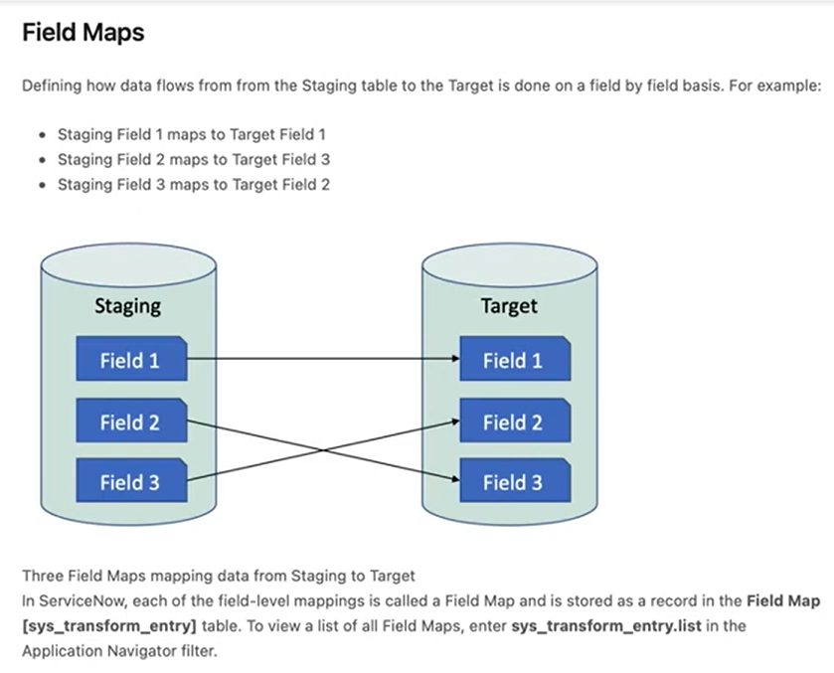

* **Field Mapping**: Field Maps enable you to map external data fields to ServiceNow fields, ensuring that the data is correctly populated in the target table.
* **Data Type Conversion**: Field Maps can perform data type conversions, ensuring that the data is correctly formatted for the target field.
* **Default Values**: You can specify default values for fields that are not present in the imported data.

**Importing, Transforming, and Mapping Data in ServiceNow**

The process of importing, transforming, and mapping data in ServiceNow involves the following steps:

1. **Data Import**: Import data from an external source, such as a CSV file or web service, into ServiceNow.
2. **Transform Map**: Apply a Transform Map to the imported data to transform and manipulate it into a format that can be easily consumed by ServiceNow.
3. **Field Map**: Use a Field Map to map the transformed data to the corresponding fields in ServiceNow.
4. **Data Insertion**: Insert the transformed and mapped data into the target table in ServiceNow.

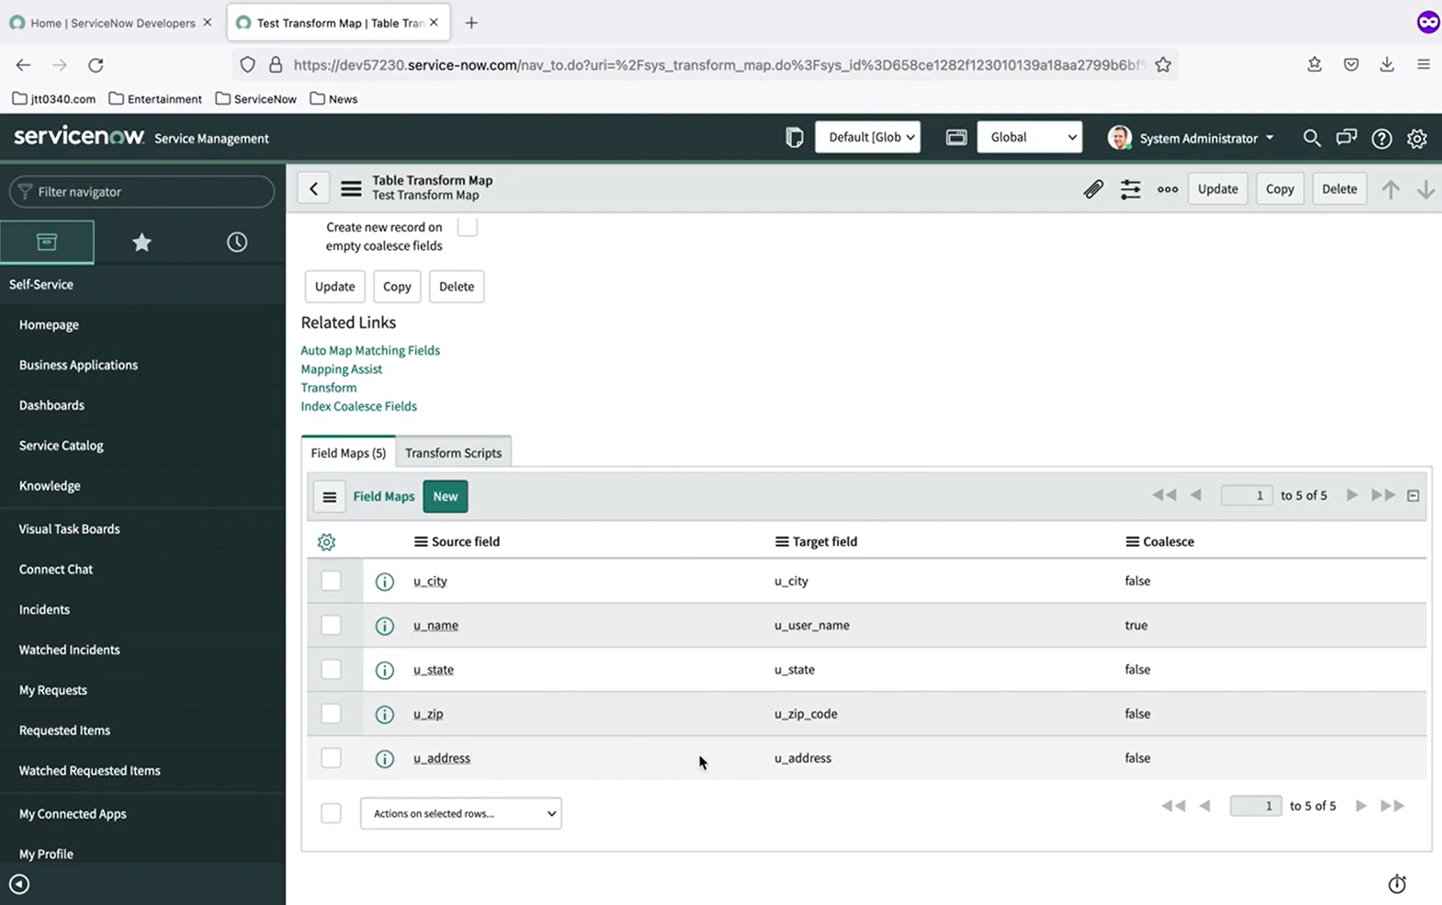

**What is Low Code No Code Development:**

what Low Code No Code software development, how it works, pros and cons, and career opportunities.

Our story begins in the land of traditional software development.

It takes us on a journey across the IT- landscape in search of something different...

Low Code No Code (LCNC) development is a software development approach that enables users to build applications with minimal or no coding required. This approach uses visual interfaces, drag-and-drop tools, and pre-built templates to simplify the development process.

In Low Code development, users with some programming knowledge can build applications using pre-built code blocks, templates, and visual interfaces. This approach requires minimal coding, but still needs some technical expertise.

On the other hand, No Code development is a more extreme version of Low Code, where users with no programming knowledge can build applications using visual interfaces, drag-and-drop tools, and pre-built templates. No Code platforms are designed for non-technical users, such as business users, to build applications without any coding required.

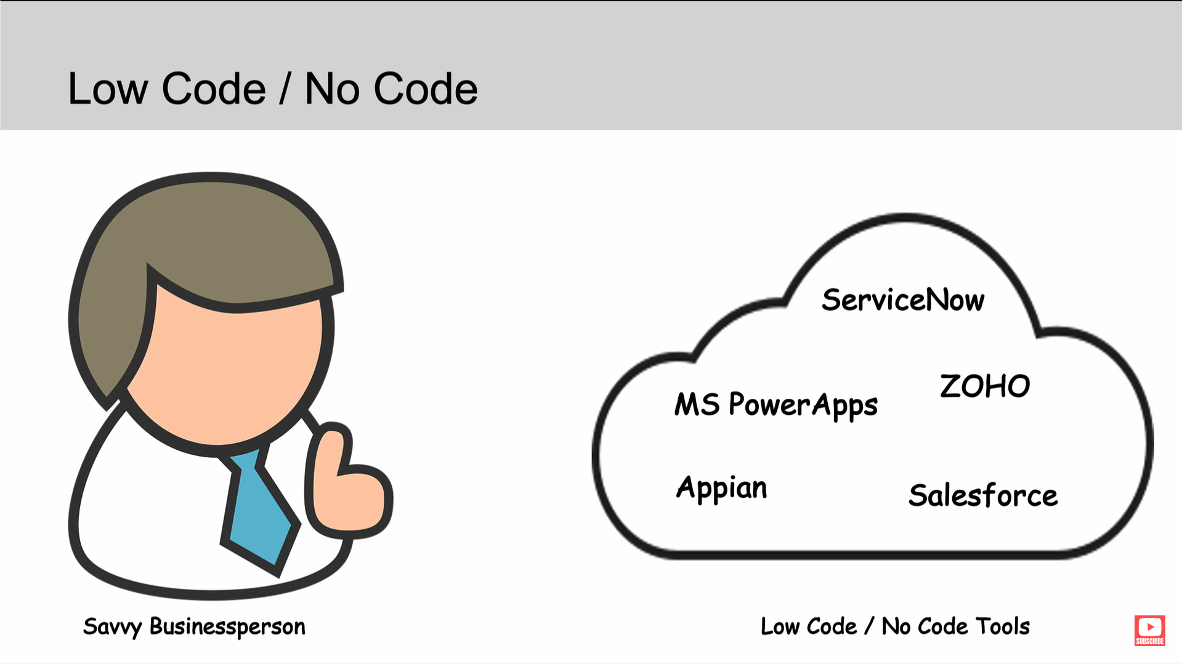

**How it Works**

Low Code No Code development platforms provide a range of tools and features that enable users to build applications quickly and efficiently. These platforms typically include:

* Visual interfaces: Drag-and-drop tools, flowcharts, and other visual interfaces that enable users to design and build applications without writing code.
* Pre-built templates: Pre-built templates and code blocks that users can customize to build applications.
* APIs and integrations: APIs and integrations that enable users to connect to external systems, services, and data sources.
* Collaboration tools: Collaboration tools that enable multiple users to work on the same application simultaneously.

**Pros and Cons**

**Pros:**

* **Faster development**: Low Code No Code development enables users to build applications quickly, reducing the time and cost of development.
* **Increased productivity**: With minimal or no coding required, users can focus on designing and building applications, rather than writing code.
* **Democratization of development**: Low Code No Code development enables non-technical users to build applications, democratizing the development process.
* **Improved collaboration**: Collaboration tools enable multiple users to work on the same application simultaneously, improving collaboration and reducing errors.

**Cons:**

* **Limited customization**: Low Code No Code development platforms may limit the level of customization possible, which can be a constraint for complex applications.
* **Dependence on the platform**: Applications built on Low Code No Code development platforms may be dependent on the platform, which can be a risk if the platform is discontinued or changed.
* **Security risks**: Low Code No Code development platforms may introduce security risks if not properly secured, as they provide access to sensitive data and systems.

**Career Opportunities**

Low Code No Code development is a growing field, with increasing demand for professionals with expertise in these platforms. Career opportunities include:

* **Low Code No Code developer**: A developer who specializes in building applications using Low Code No Code development platforms.
* **Citizen developer**: A non-technical user who builds applications using Low Code No Code development platforms.
* **Low Code No Code consultant**: A consultant who advises organizations on the use of Low Code No Code development platforms and helps them implement these platforms.

Overall, Low Code No Code development is a powerful approach that enables users to build applications quickly and efficiently, with minimal or no coding required. While it has its limitations, it offers many benefits, including faster development, increased productivity, and democratization of development.

https://www.youtube.com/watch?v=lB7aRYmP5QU watch the vedio and get me the key points

After watching the video, I've extracted the key points for you:

**Introduction**

* The video introduces the concept of low-code no-code software development and its benefits.
* The story is presented in a narrative style, with three main characters: the Savvy Businessperson, the IT Superstar, and the Wall.

**The Problem**

* The Wall represents the barrier between the business person and the IT team, causing frustration and delays in software development.
* The traditional software development process is cumbersome, with requirements being tossed back and forth between the business person and the IT team.

**The Solution**

* Low-code no-code software development is introduced as a solution to break down the technical barriers between business people and IT.
* Low-code no-code platforms provide intuitive, easy-to-use tools that hide the complexity of traditional IT tasks.

**Benefits**

* Improved agility and speed to market
* Lower costs
* Increased automation

**Examples**

* ServiceNow is mentioned as an example of a company offering low-code no-code capabilities.
* Other companies, such as Microsoft, Zoho, Appian, and Salesforce, are also mentioned as having low-code no-code offerings.

**Opportunities**

* Business people are empowered to think creatively about their work and simplify, automate, or eliminate tasks.
* Developers are encouraged to learn the business side and support the business people, rather than being the "tail that wags the dog".

**Conclusion**

* The video concludes by encouraging viewers to explore low-code no-code software development and provide feedback.
* The narrator, who is also the IT Superstar, pokes fun at himself and encourages developers to be open to change and to always look for opportunities to eliminate their own jobs by automating tasks.

